AR SUMMARY REPORT

- Open Province Accounts Receivable Monitoring.
- Check for SJRs that are closed/paid. Remove from Monitoring and Aging.
- Encode in Province Income > Receivables Collected
- Copy all SJRs that have outstanding balances into AR Summary Report.
- Check for Accounts Receivables for the month.
How to generate Service Collection Report from Quadrant:
- Open Quadrant. Go to Service Collection.
- Fill up SJR Date and Warehouse. Apply Filter. Download CSV.
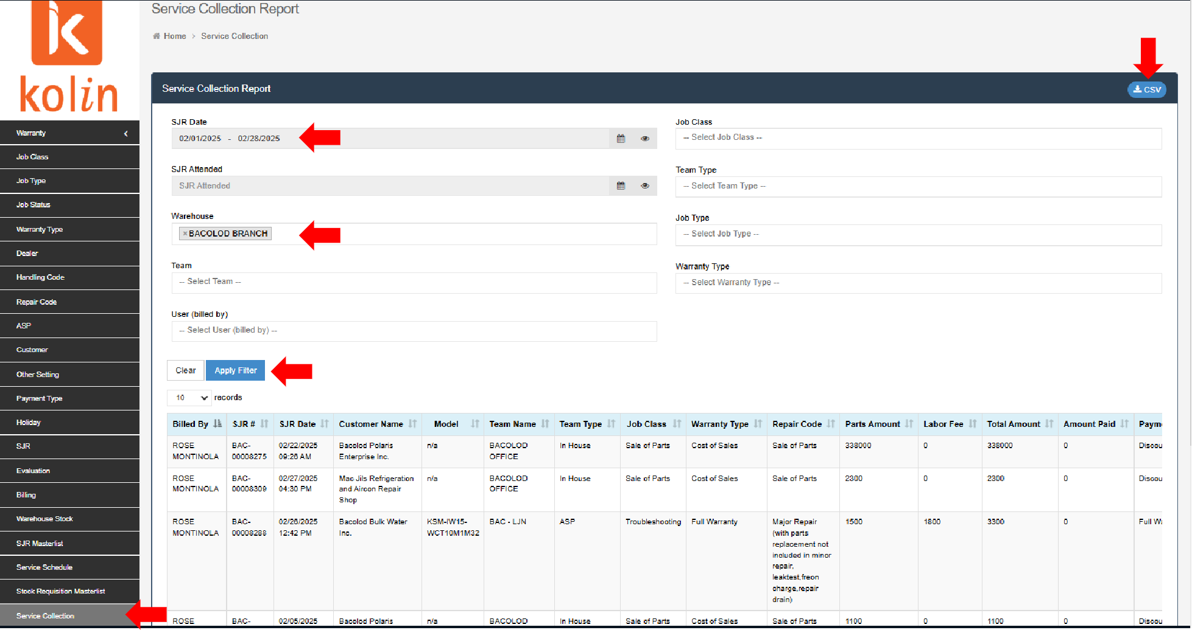

- Open File. Sort by Payment Type. Remove Warranty.
- Sort by Job Class. Cross-check with SJR Masterlist.
How to generate SJR Masterlist from Quadrant:
- Open Quadrant. Go to SJR Masterlist.
- Fill up SJR Date and Time Called and Location. Apply. Download CSV.
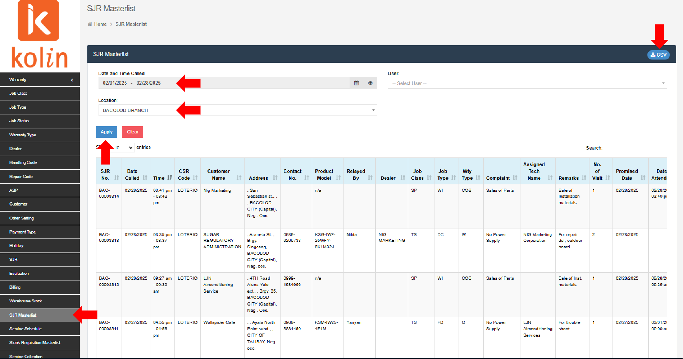

- Once validated, copy SJR Code. Open Quadrant. Go to SJR and paste SJR Code. Search. Open SJRs.
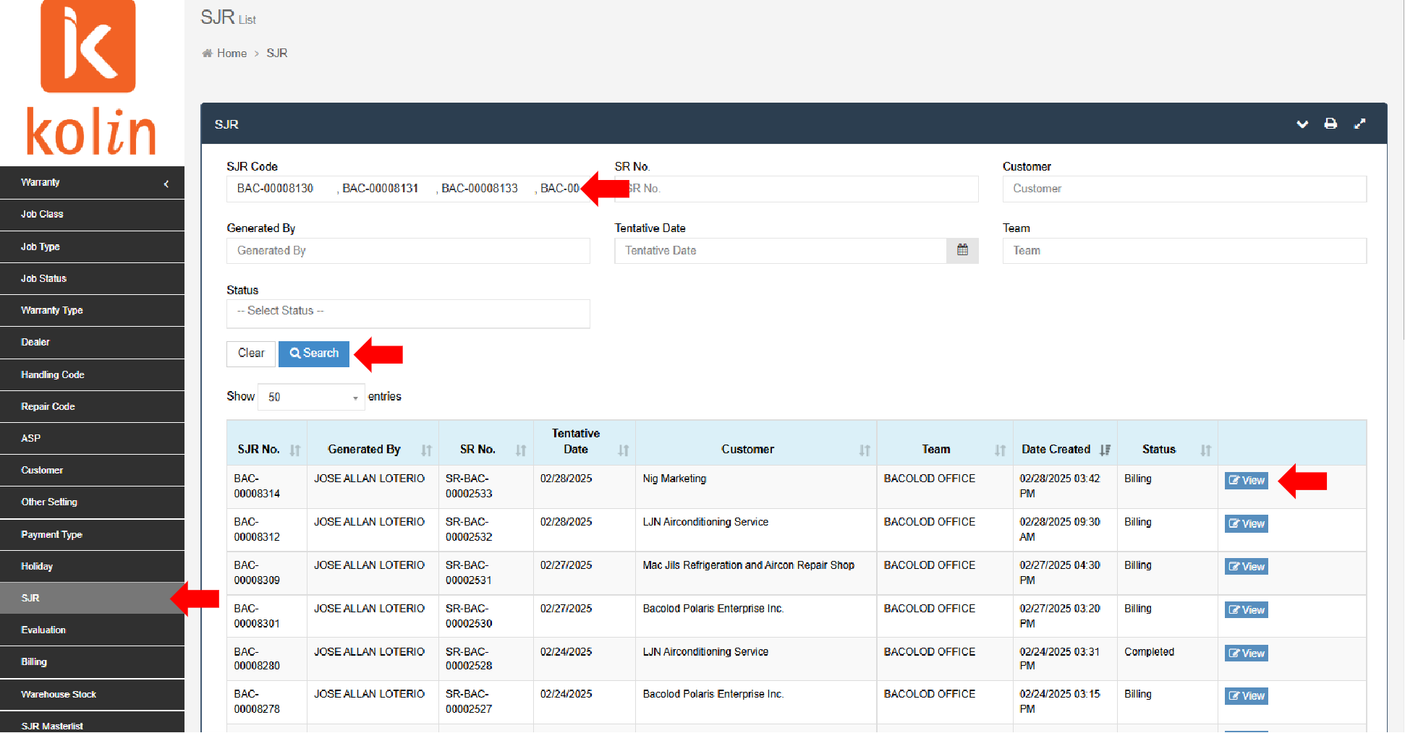

- Check and list all SJRs with balance/receivable on AR Summary Report.
- Compute Total Accounts Receivable for the month.
- Cross-check Accounts Receivable SJRs with own records. Encode missing SJRs.
- Finish all seven (7) provinces.
- Endorse to Ms. Richell for signature.
- File in respective AR Summary Folder.

