ASP PERFORMANCE EVALUATION REPORT

- Received through Ms. Rochelle/Ms. Sheila. (Mostly 1st to 2nd week)
- Open ASP Billings Record excel and Performance Evaluation excel.
- Crosscheck ASP Billings Record with Performance Evaluation.
- Make sure that all Billings received during the month are evaluated.
- Always check the Evaluation Period of the ASP Performance Evaluation Report.
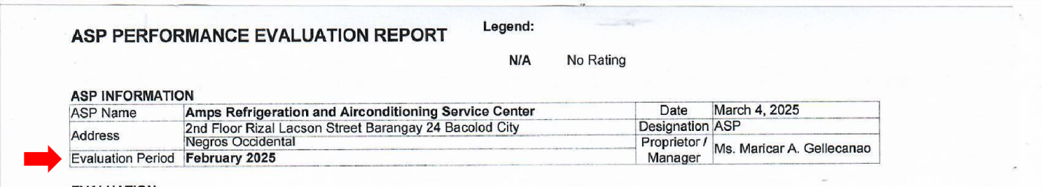
- Sort all ASPs with scores from those without scores.
- For those with scores.
  - Highlight ASPs with final scores below 2.90 on excel. Photocopy SOA for reference. Attach SOA references on Evaluation paper.
  - Under Evaluation, fill up Timely Submission and Accuracy of Billing. (Score, Score Equivalent, and Final Rating)
  - Under Criteria, Fill up score and signature for (6) Timely Submission and (7) Accuracy of Billing.
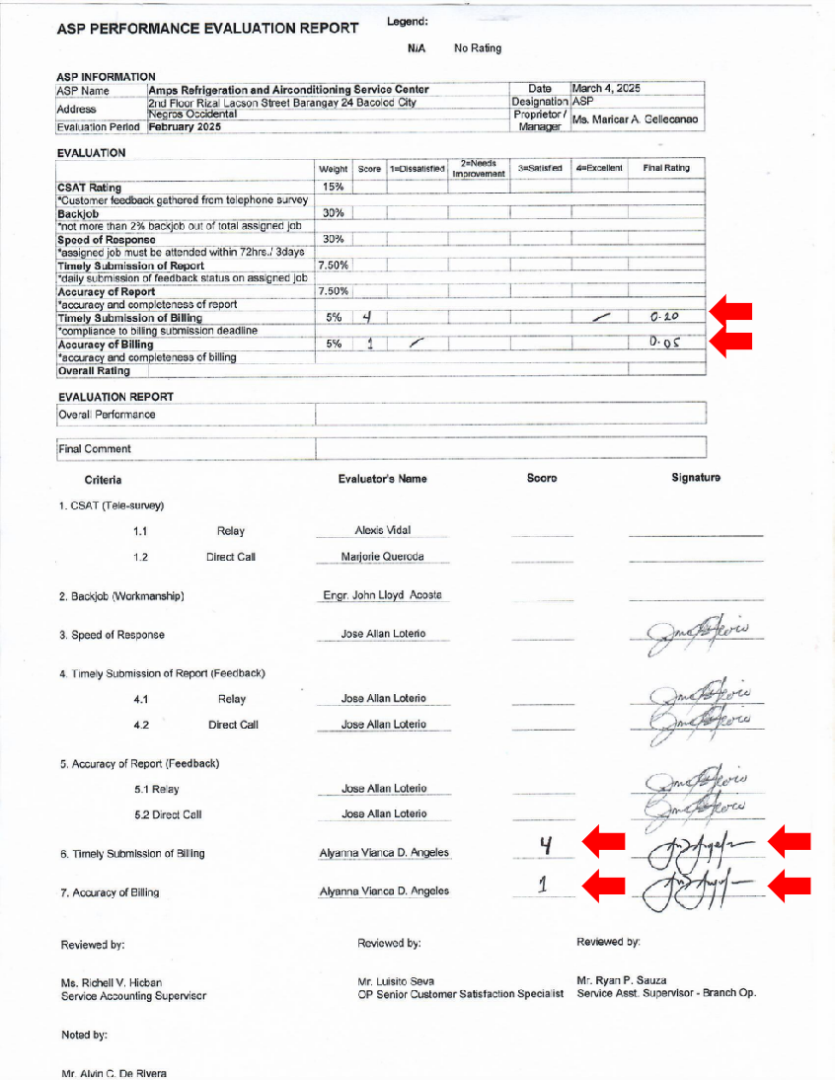
- For those without scores.
  - Under Criteria, Fill up score with N/A and signature for (6) Timely Submission and (7) Accuracy of Billing.
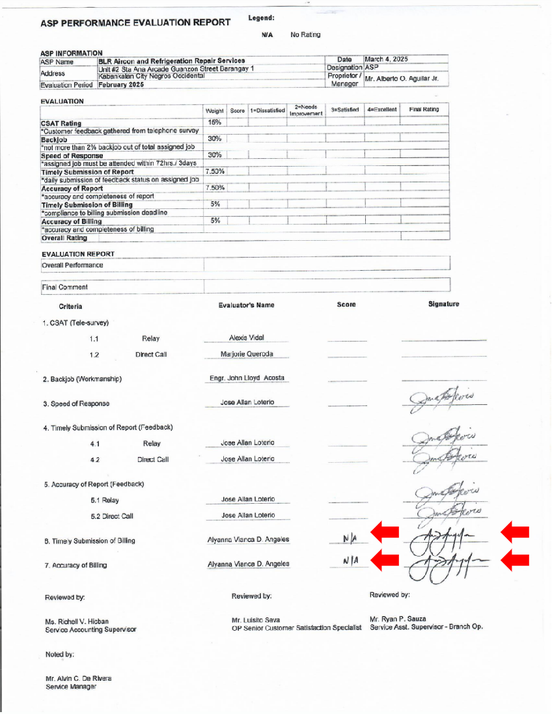
- Arrange ASPs alphabetically per province.
- Finish all 7 provinces.Arrange provinces alphabetically.
- Endorse to Ms. Richell for signature.
- Endorse to Ms. Marjorie of OP.
- Inform Ms. Rochelle/Ms. Sheila when you have endorse the ASP Performance Evaluation Report to OP.

