CHECKING OF BLUE COPY SJR

- Receive through Sir Noel (pouched to Head Office) or Ms. Anngelica.
- How to check entries of blue copy SJR:
- Open Quadrant. Go to SJR.
- Encode SJR Code. Search. Open SJRs.
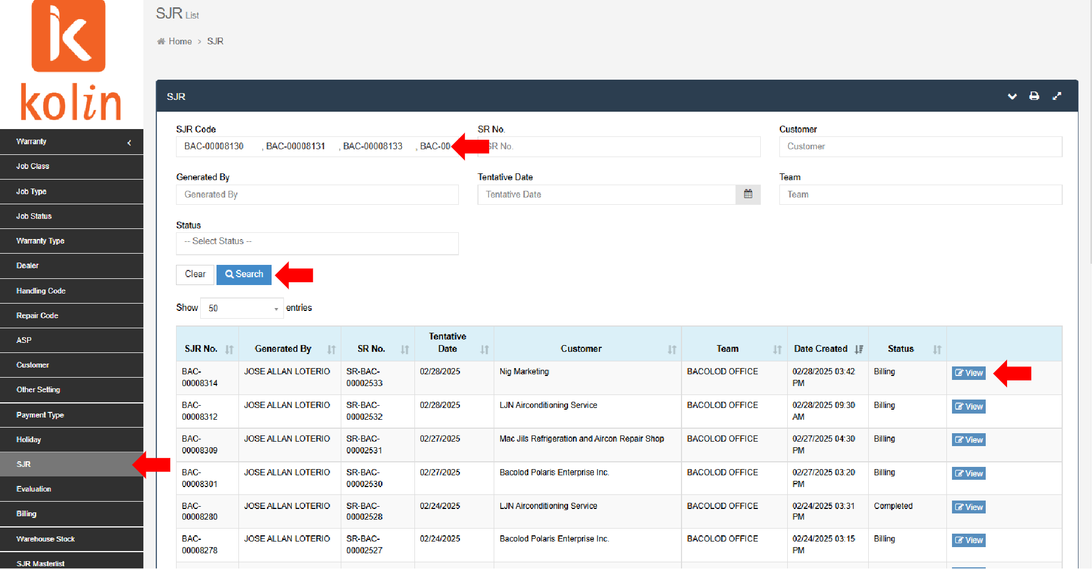

- Ensure right entries of details. Cross-check details of blue copy SJR with Quadrant.
- Check Information details.
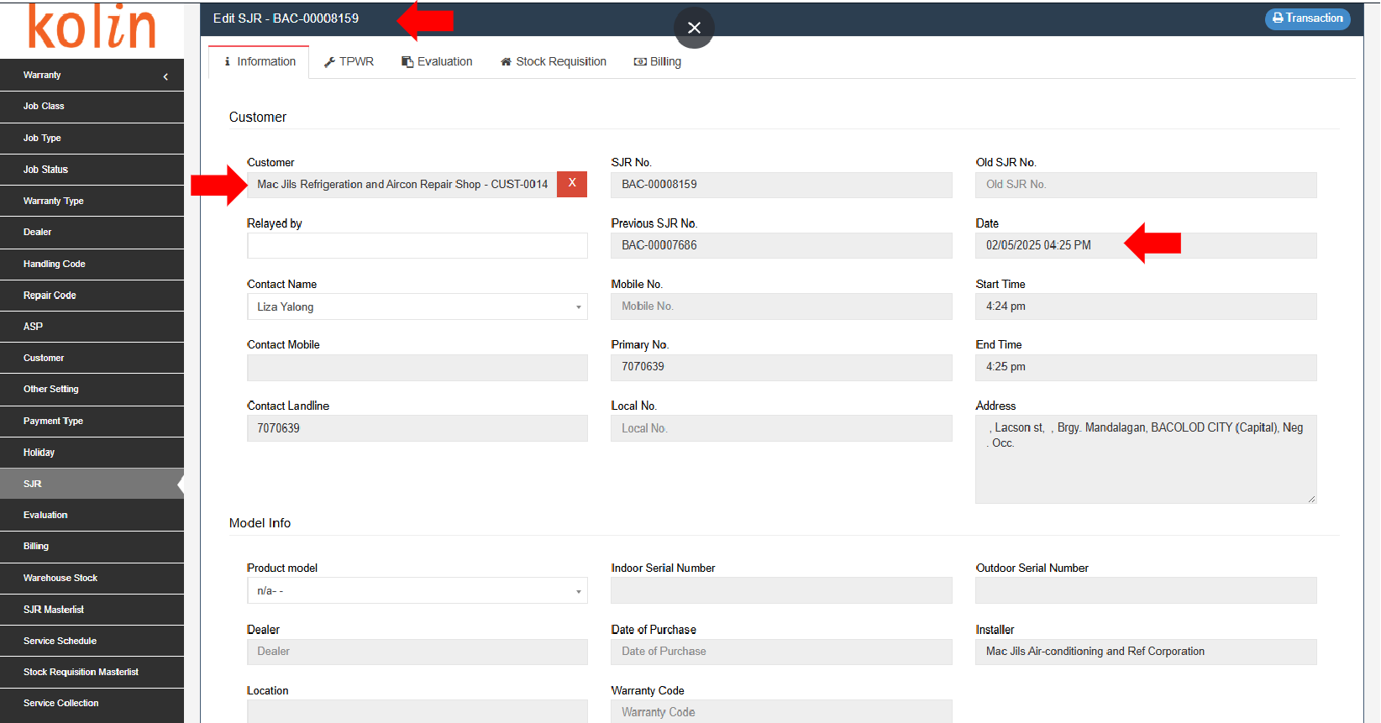

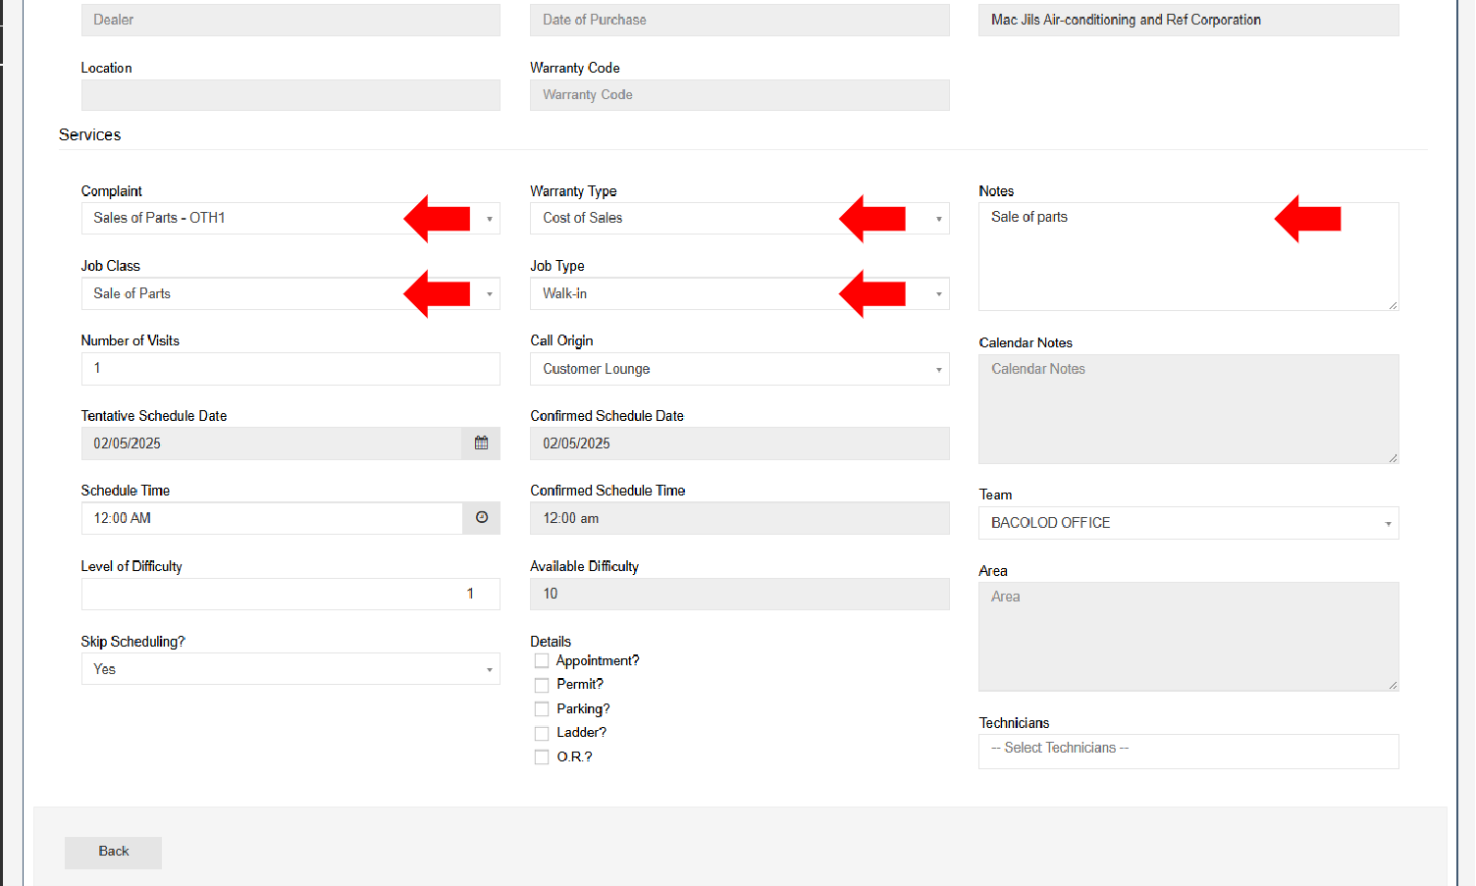
- Check Evaluation details.
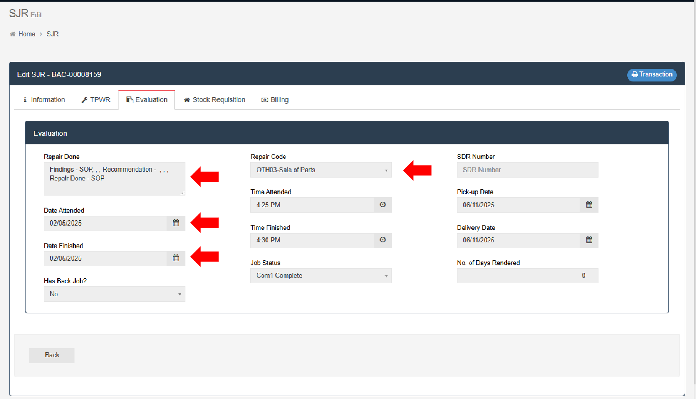

- Check Stock Requisition details.
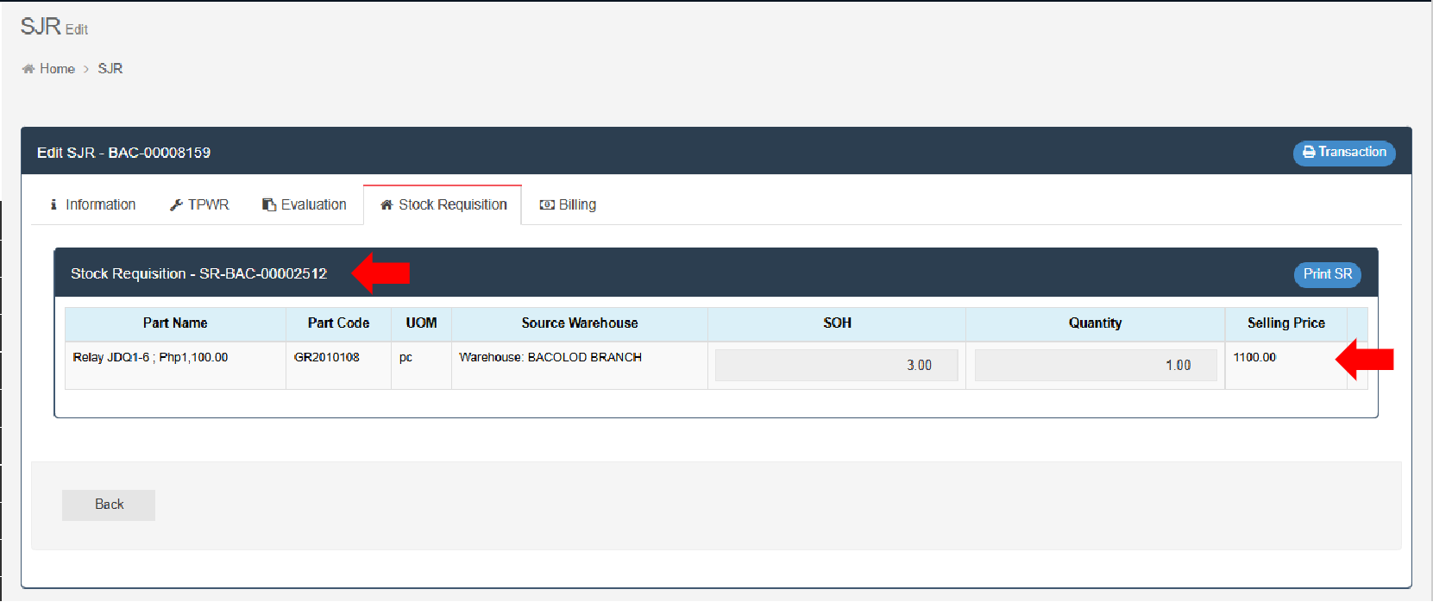
- Check Billing details.
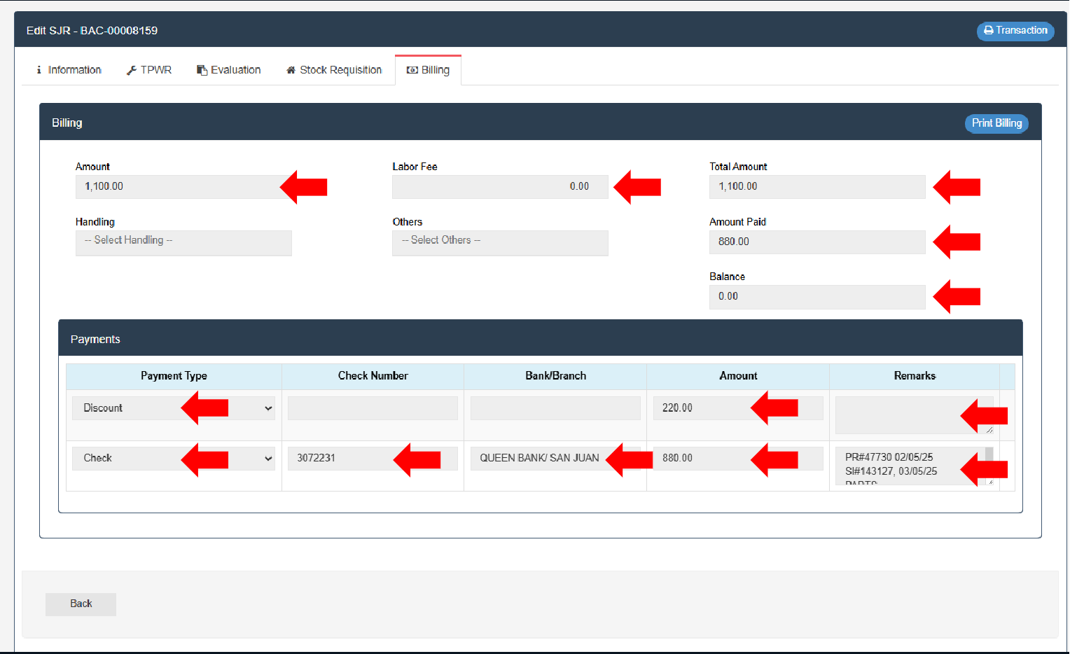
- Check blue copy SJR details.

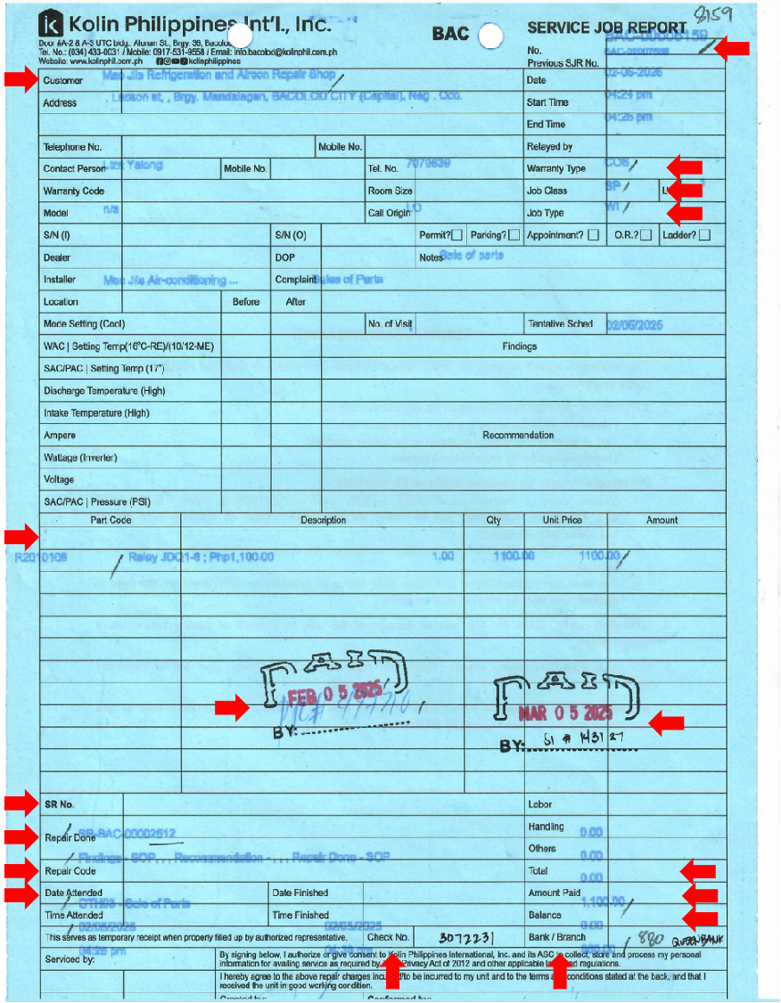
- After validating entries, record income.
- Encode cash collections in Province Service Income (Month) > Province > Cash Collections.
- File blue copy SJR in respective Province SJR folder.
- If there is Receivable/Balance, encode in Province Service Income (Month) > Province > Accounts Receivable.
- Record in Province Accounts Receivables Monitoring.
- Record in Aging.
- File blue copy SJR in respective Province For Collection folder.

