PROCESSING OF ASP BILLINGS (REBATE CLAIMS)

- Receive through Sir Noel. (Pouched to Head Office)
- Stamp Received on ASP Statement of Account (SOA)
- Record to ASP Billing Report. Fill column on designated province.
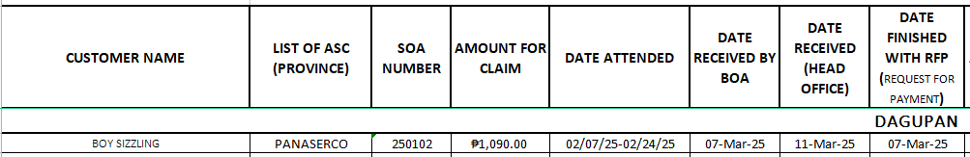
- Check attachments.
- Request for Payment Slip (RFP)
- Statement of Account (SOA)
- Service Job Report (SJR)
- Stock Requisition (SR) (only if there is parts replacement)
- ASP Service Report
- Official Receipt/ Sales Invoice/ Delivery Receipt
Note: Visible Model, SN, & Date of Purchase (DOP)
If not, trace from Masterlist (CNC)
- Validate and check the documents properly.
- Evaluate and Bill SJR on Quadrant.
- Once validated, evaluated, and billed, put in a fastener.
- If there is transpo included in SOA/RFP, for validation of Sir Ryan.
- To ensure validity of claim, for validation of Engr. Mau/ Engr. Acosta.
- Check for and remove Invalid Claims. File on Deduction Claims Folder.
- Check whether ASP is Preferred.
- Compute for Total Claim Amount. List units on RFP
- Total Number of Units
- Job Done(Repair Code)/Unit Model
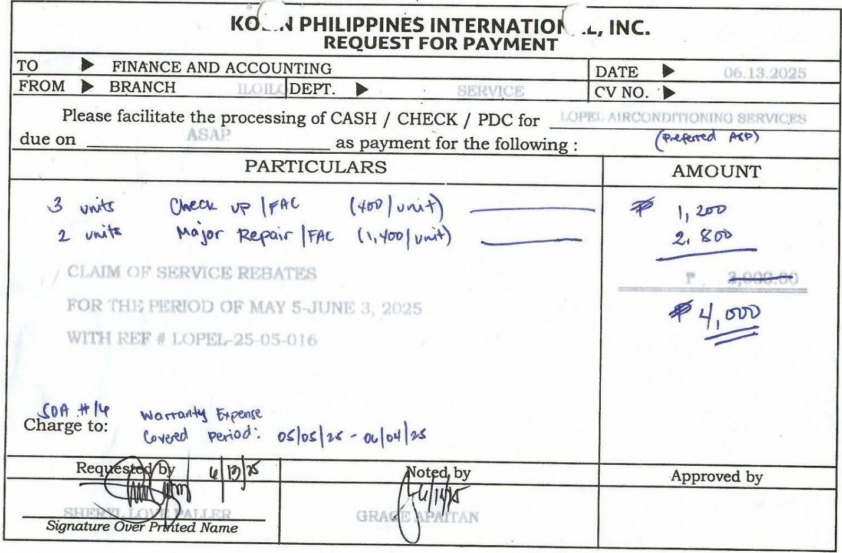
- (Amount/Unit) Total Amount

- Use the calculator to print receipt and validate Total Amount, attach the receipt to RFP. Highlight Total Amount on RFP and Receipt.
- Charged to : (RFP and Receipt)
- SOA #
- Warranty Expense (if warranty)
- Ads and Promo (if installation)
- Covered Period (Date Attended)
- Update ASP Billing Report.
- Encode in Province Performance Evaluation.
- Encode in Province Receiving Summary. Print 2 copies(Audit&Service Acctng.)
- Inform BOA about the changes in Amount or Invalid Claims.
- Endorse to Ms. Richell for validation and signature.
- Endorse to Sir Patrick for Audit.
- Endorse to Ms. Rhen for signature.
- Photocopy 2 copies of RFP and SOA.
- RFP, SOA (Sir Kiko, attach to folder)
- SOA, RFP (For Filing)
- Update ASP Billing Report.
- Endorse to Sir Kiko with 1 photocopy of RFP and SOA.
- File the receiving copy, photocopied SOA, and photocopied RFP in respective Rebate Claims Folder.

