PROCESSING OF RENTALS AND UTILITIES

RENTALS

- It should be processed before 15th of the month.
- Get contract from Cabinet 4, Door 2.
- Photocopy the first page of the contract only.
- Prepare RFP. Fill up:
- Date
- Branch
- Department
- For & Due Date
- Particulars & Amount
- Charged to: (Previous Bill/Number of Months before the contract expires)
- Signature over Printed Name
- Encode in Utility Excel record.
- Endorse to Ms. Richell for validation and signature.
- Photocopy SOA with RFP. File in Rental Payments Folder.
- Encode in Utilities/Rentals/Refund Payments Receiving Logbook.
- Endorse to Audit, look for Sir Darel.

UTILITIES

ELECTRICITY AND WATER

- Check for due dates. Remind BOO/BOA.
- Hard copies are received through Sir Noel. Soft/scanned copies are received through Ms. Richelle or from BOO/BOA.
- Stamp Receive on bill. Check details.
- Prepare RFP. Fill up:
- Date
- Branch
- Department
- For & Due Date
- Particulars & Amount
- Charged to: (Previous Bill)
- Signature over Printed Name
- Encode in Utility Excel record.
- Endorse to Ms. Richell for validation and signature.
- Photocopy Bill with RFP. File in Utility Payments Folder.
- Encode in Utilities/Rentals/Refund Payments Receiving Logbook.
- Endorse to Audit, look for Sir Darel.

PLDT

- Open PLDT Bills Online. Fill up username and password. Log in.
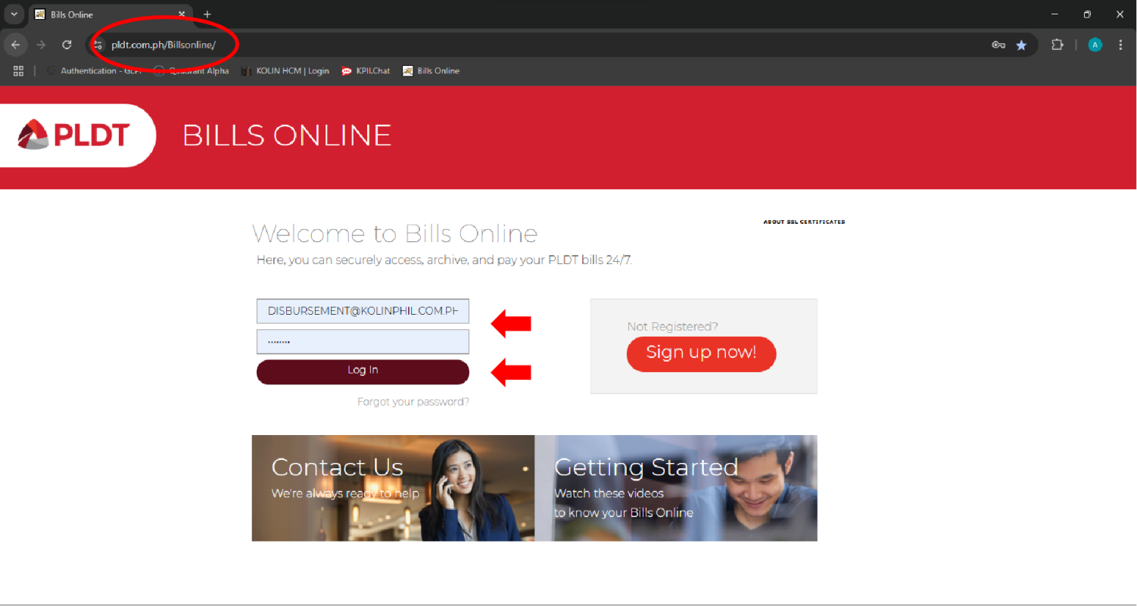
- Go to Current Bills > 62853115 > Various Accounts > Account No.
Note: Invoice Date is every 17th of the month. Check for SOA from time to time. (Usually every 25th)
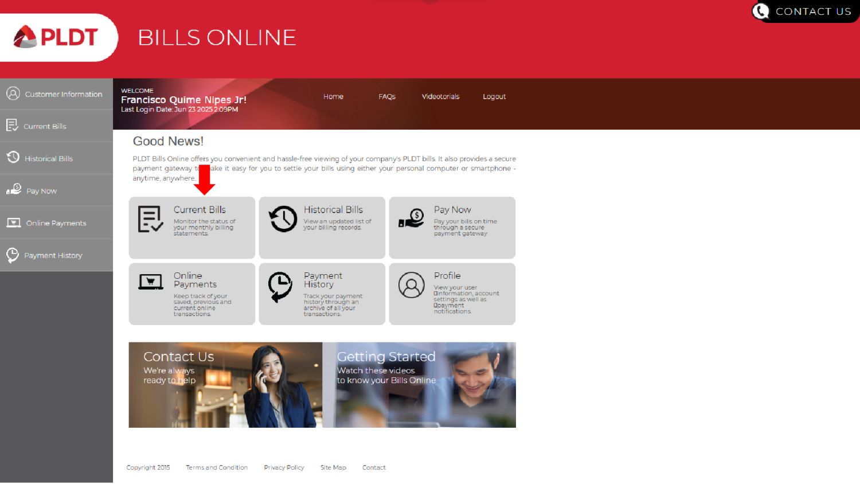

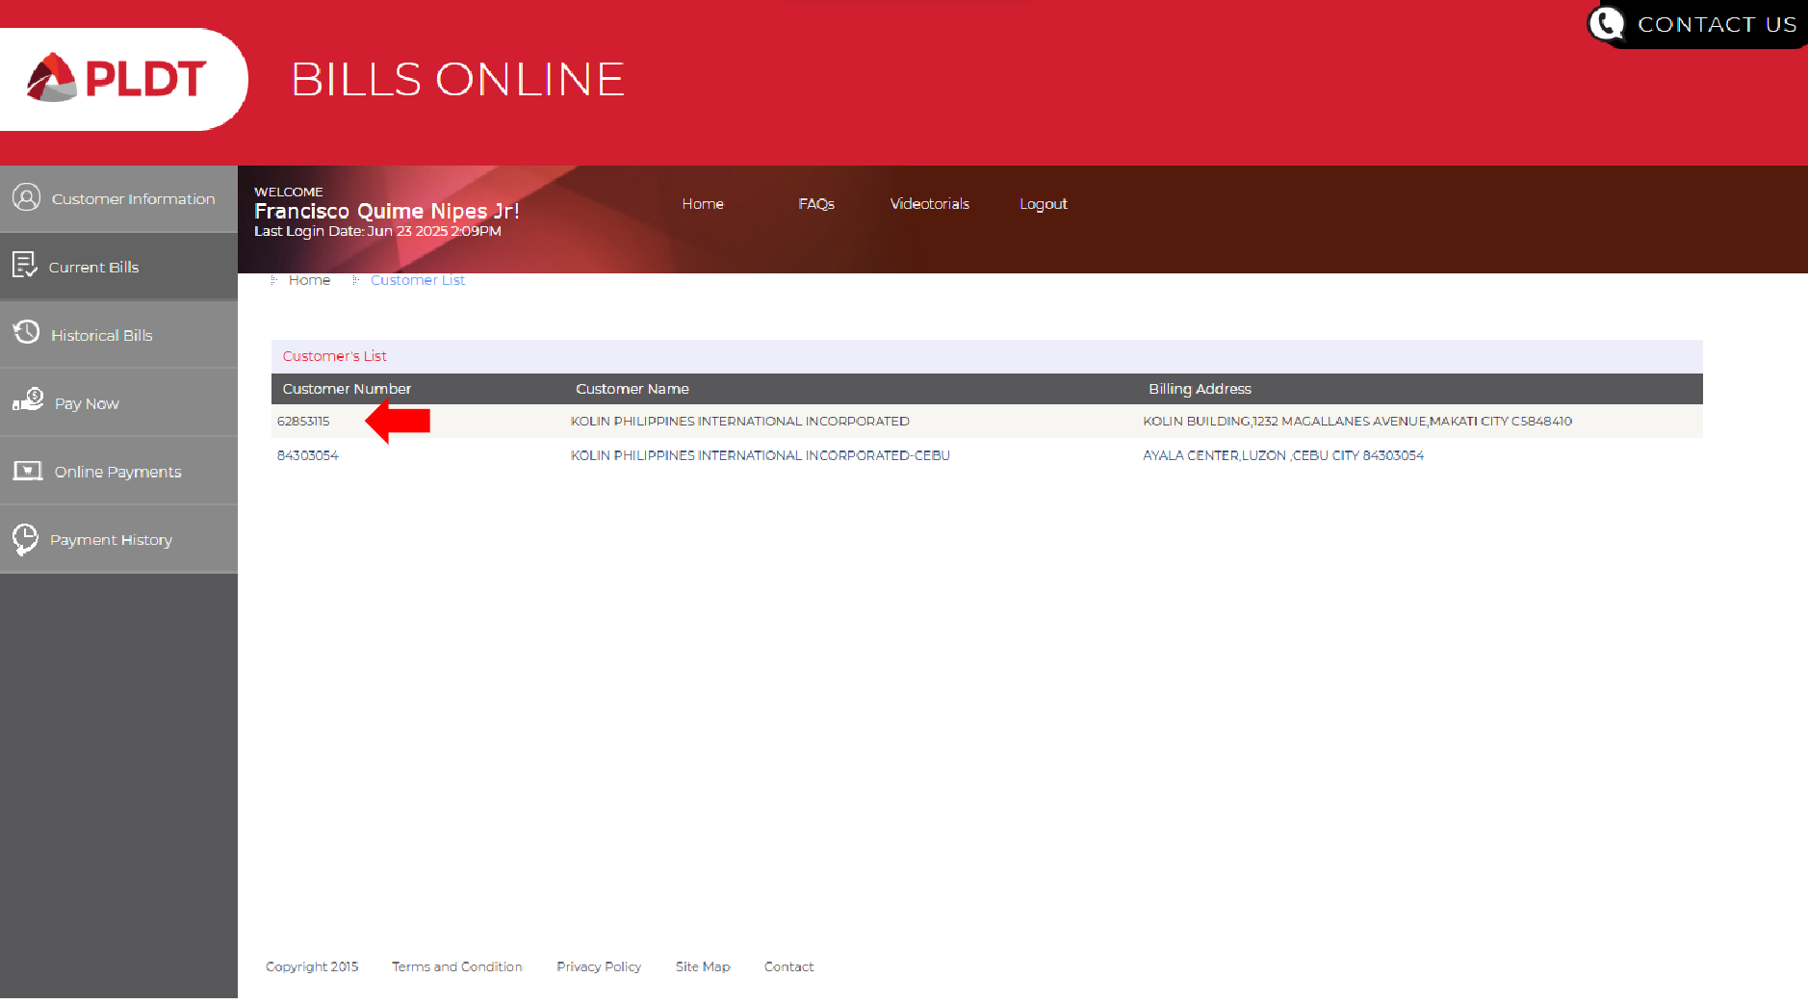
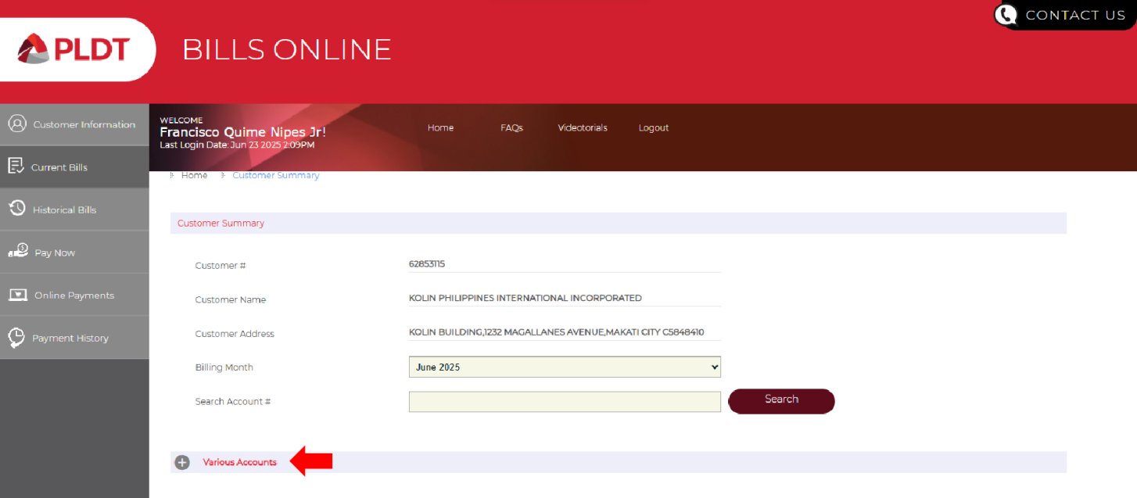
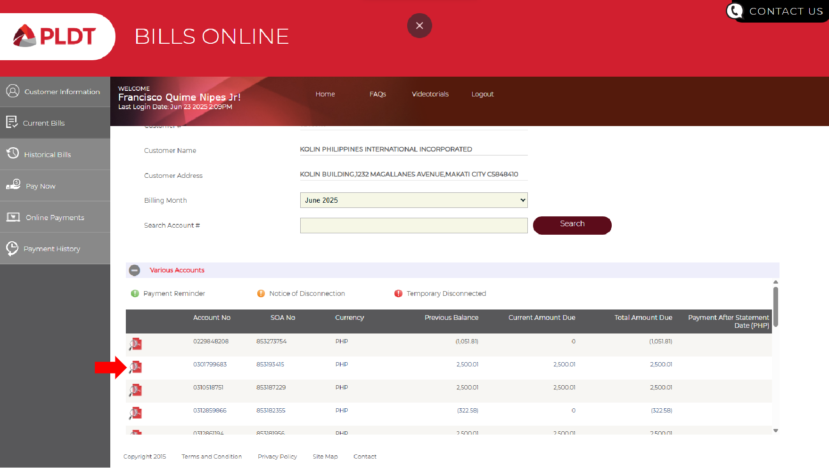

- Open SOA. Print SOA.
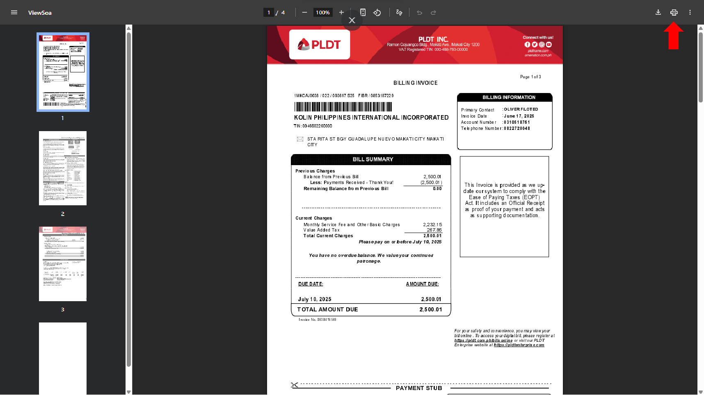
- Indicate the Province on the upper right portion of the SOA.
- Stamp Receive on SOA.
- Prepare RFP. Fill up:
- Date
- Branch
- Department
- For & Due Date
- Particulars & Amount
- Charged to: (Previous Bill)
- Signature over Printed Name
- Encode in Utility Excel record.
- Endorse to Ms. Richell for validation and signature.
- Photocopy SOA with RFP. File in Utility Payments Folder.
- Encode in Utilities/Rentals/Refund Payments Receiving Logbook.
- Endorse to Audit, look for Sir Darel.

PROVINCE PLDT ACCOUNT NO.

BAC - 0312-861194
CDO - 0312-876256
DAV - 0310-518751
ILO - 0301-799683
PAM - 658-358995

FOR BACOLOD PLDT LANDLINE (ACC. NO. - 862-60875)

- Download SOA.
- Send SOA to BOO (Ms. Rose Montinola) for Bill payment.

