REVENUE SUMMARY REPORT

- Request for Revenue Summary from BOO.
- Save file in Province Income Summary 2025 > Month
- Fit Summary in 1-2 pages. Print.
- Generate Service Collection Report from Quadrant.
- Open Quadrant. Go to Service Collection.
- Fill up SJR Date and Warehouse. Apply Filter. Download CSV.
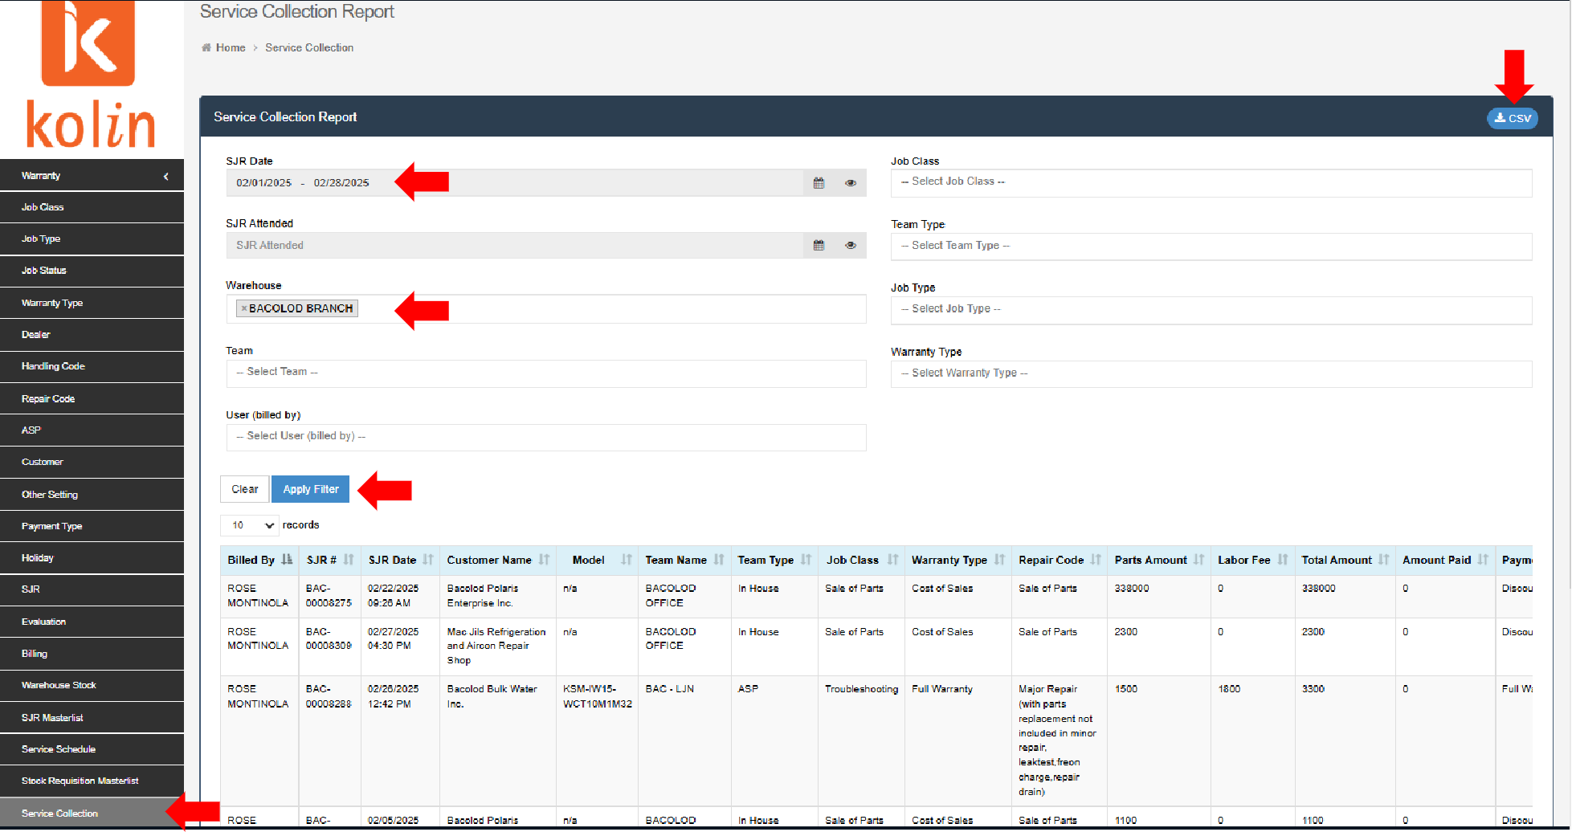

- Open File. Sort by Payment Type. Remove Warranty.
- Sort by Job Class. Cross-check with SJR Masterlist.
How to generate SJR Masterlist from Quadrant:
- Open Quadrant. Go to SJR Masterlist.
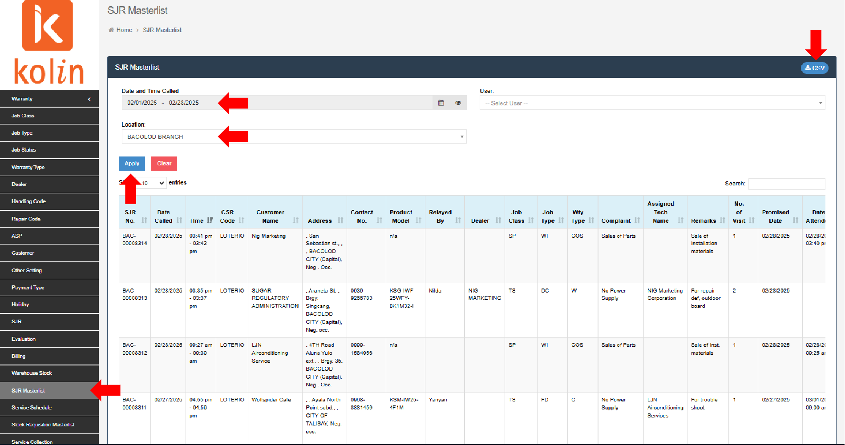
- Fill up SJR Date and Time Called and Location. Apply. Download CSV.

- Once validated, copy SJR Code. Open Quadrant. Go to SJR and paste SJR Code. Search. Open SJRs.
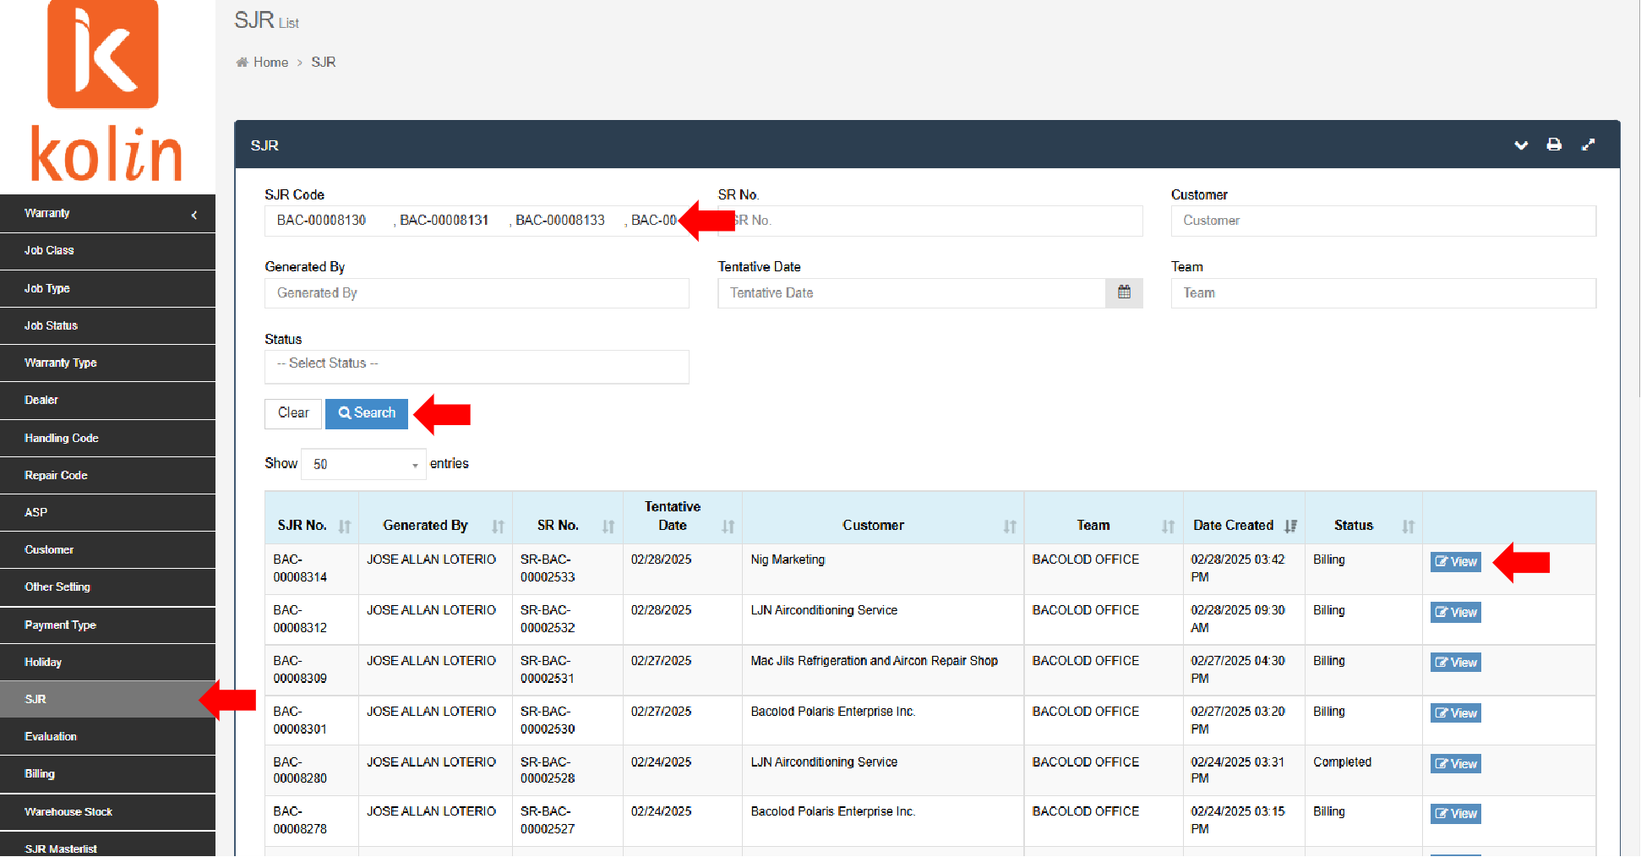

- Cross-check Revenue Summary with SJRs. Compute Total Revenue.
- Cross-check Revenue Summary with own records. Encode missing SJRs.
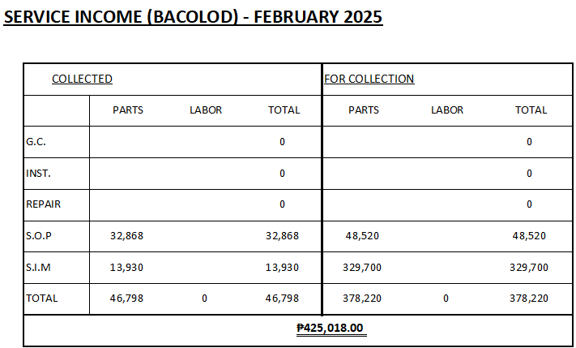
- Encode total in Service Income Sheet. Print. Highlight Total Revenue.
- Relay any lapses/changes/concerns to BOO. Ask for missing blue copy SJRs. If pouched, ask for tracking number.
- Finish checking all seven (7) provinces.
- Endorse to Ms. Richell for checking and record purposes.
- File in respective Service Revenue Folder.

