SERVICE INVOICE (PINK COPY)

- Receive through Ms. Princess. Check if all listed SI # are given before signing.
- Get the blue copy SJR in the Province For Collection folder.
- Cross-check details of SI with SJR.
- Received from: (ASP Name)
- Amount
- SJR Code
- If Parts / Installation Materials
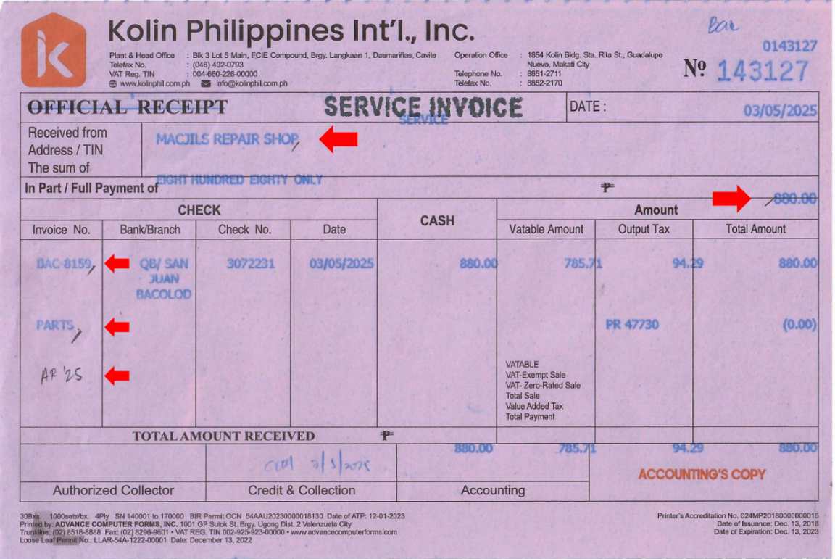
- Write AR’(Year) if Accounts Receivable

- After validation, Paid stamp with Date and SI # on blue copy SJR. If check payment, also write check no. and bank/branch on designated column.
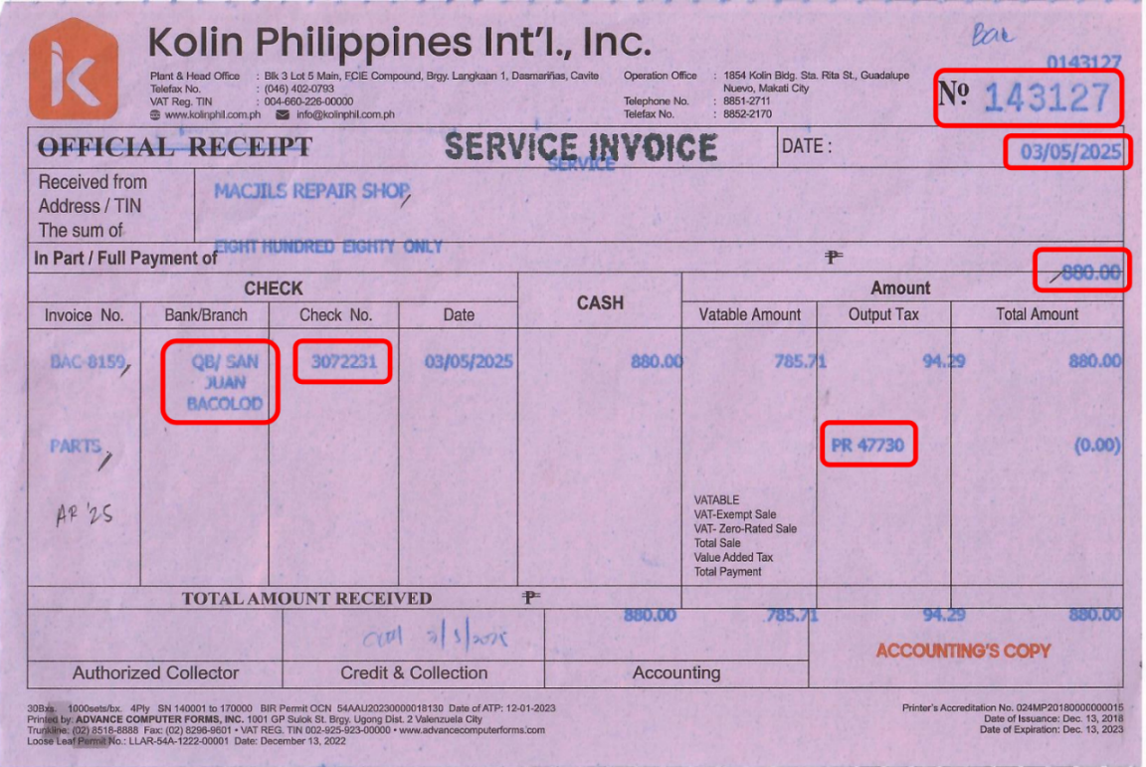

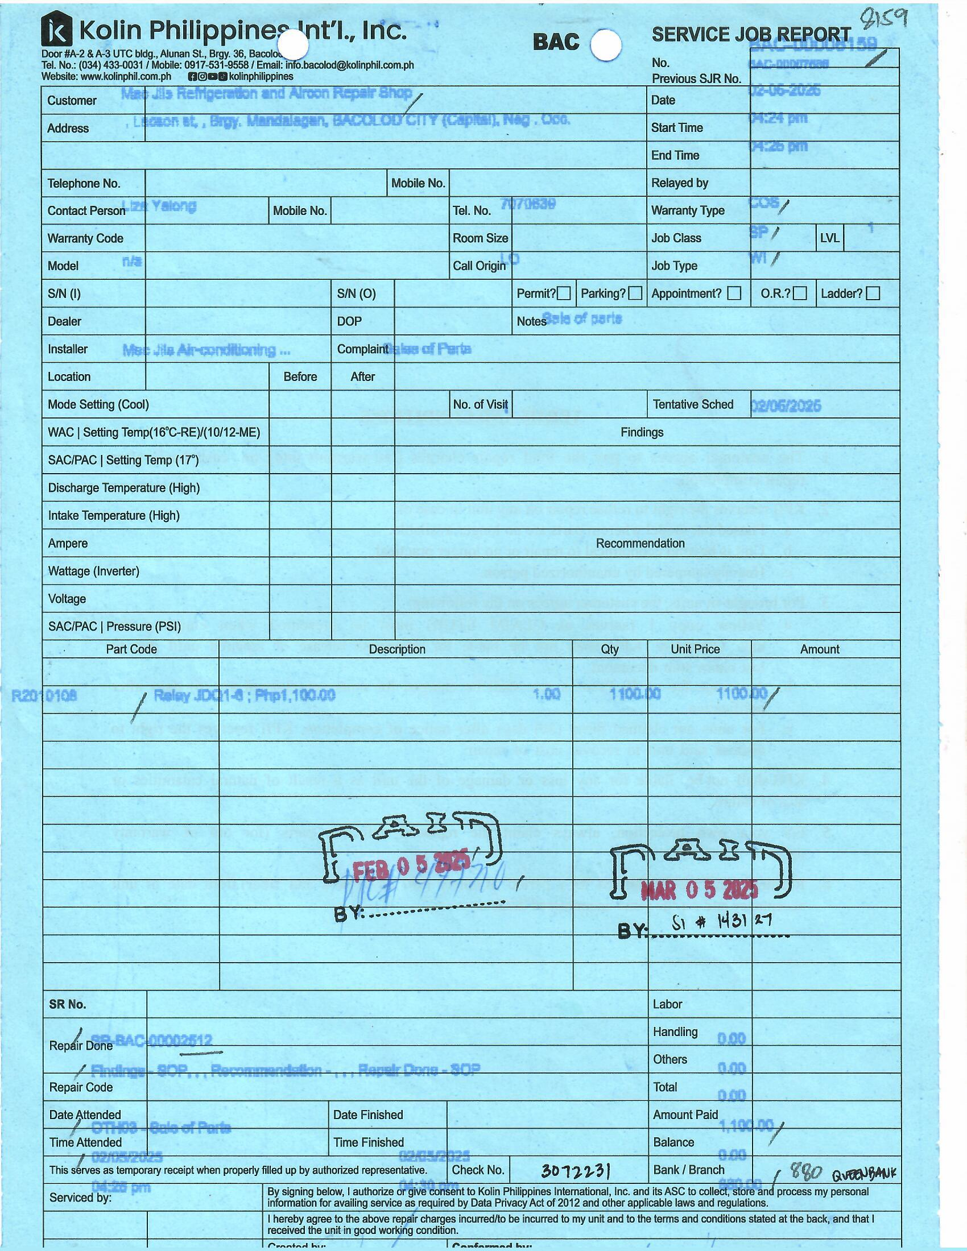

- Close SJR on Quadrant.
How to bill SJR:
- Open Quadrant. Go to Billing and input SJR Code. Search. Open SJR.
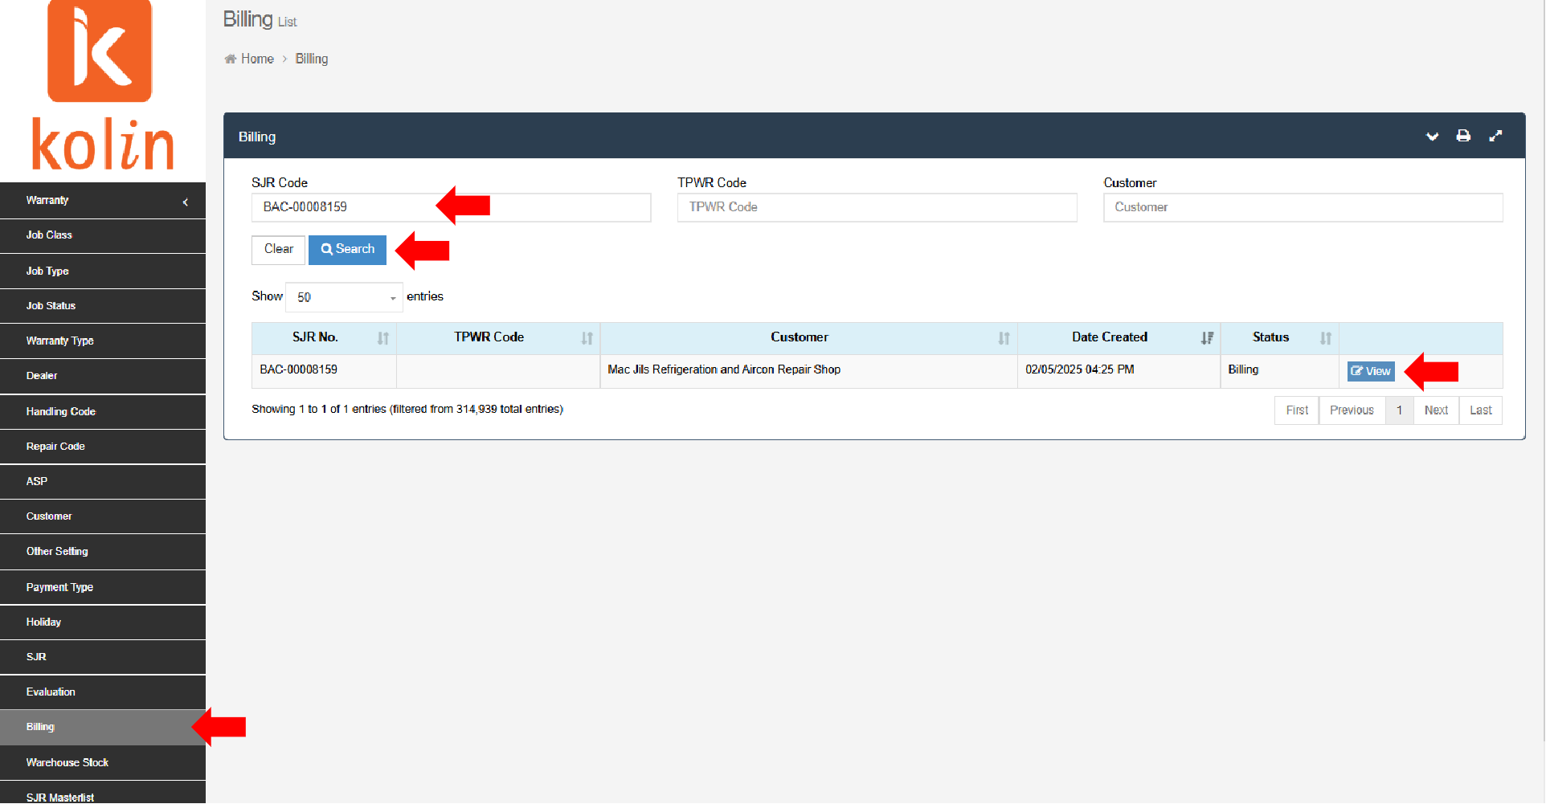

- Check balance in Quadrant if it has the same amount with the SI. If the amount is insufficient, only close the amount stated on SI.
- Add Payment. Select appropriate Payment Type. If payment type is check, input Check Number and Bank/Branch. Input amount based on SI. On the Remarks column, input the following:
- PR#, Date of PR (mm/dd/yy)
- SI#, Date of SI (mm/dd/yy)
- If PARTS/ INST’N MAT
- If accounts receivable (AR’(Year))
- Double check if all details are correct. Proceed to SAVE. Billed.
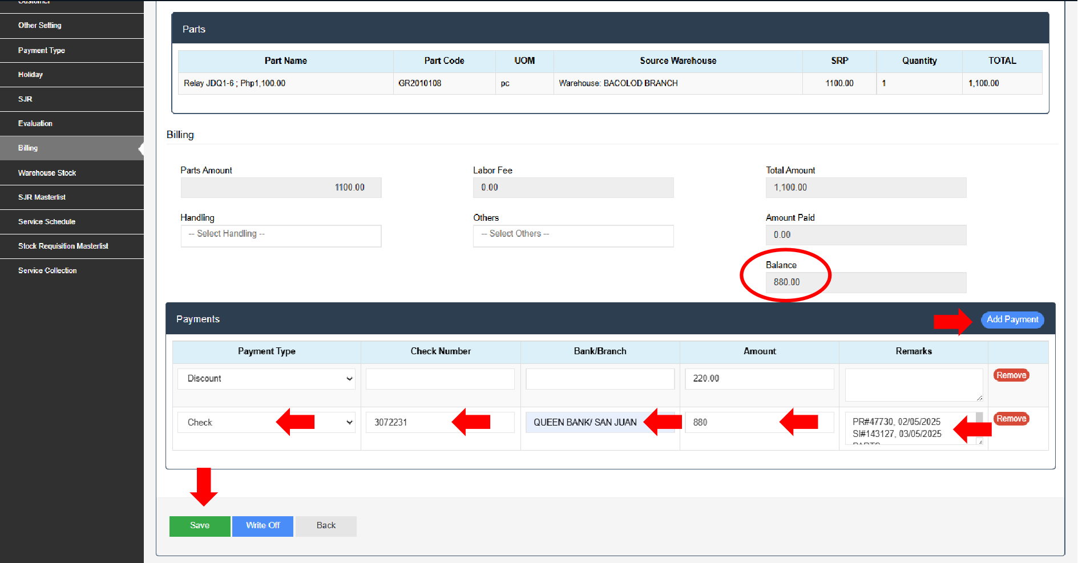

- Encode in Province Service Income (Month) > Province > Receivable Collected.
- Close and Delete in Province Accounts Receivables Monitoring.
- Close and Delete in Aging.
- File blue copy SJR in respective Province SJR folder.
- Return the Service Invoice (pink copy) to Ms. Anngelica.

