SJR EVALUATION AND BILLING GUIDE

SJR EVALUATION
- Generate Service Schedule from Quadrant.
- Open Quadrant. Go to Service Schedule.
- Fill up SJR Date and Location. Apply Filter. Download CSV.
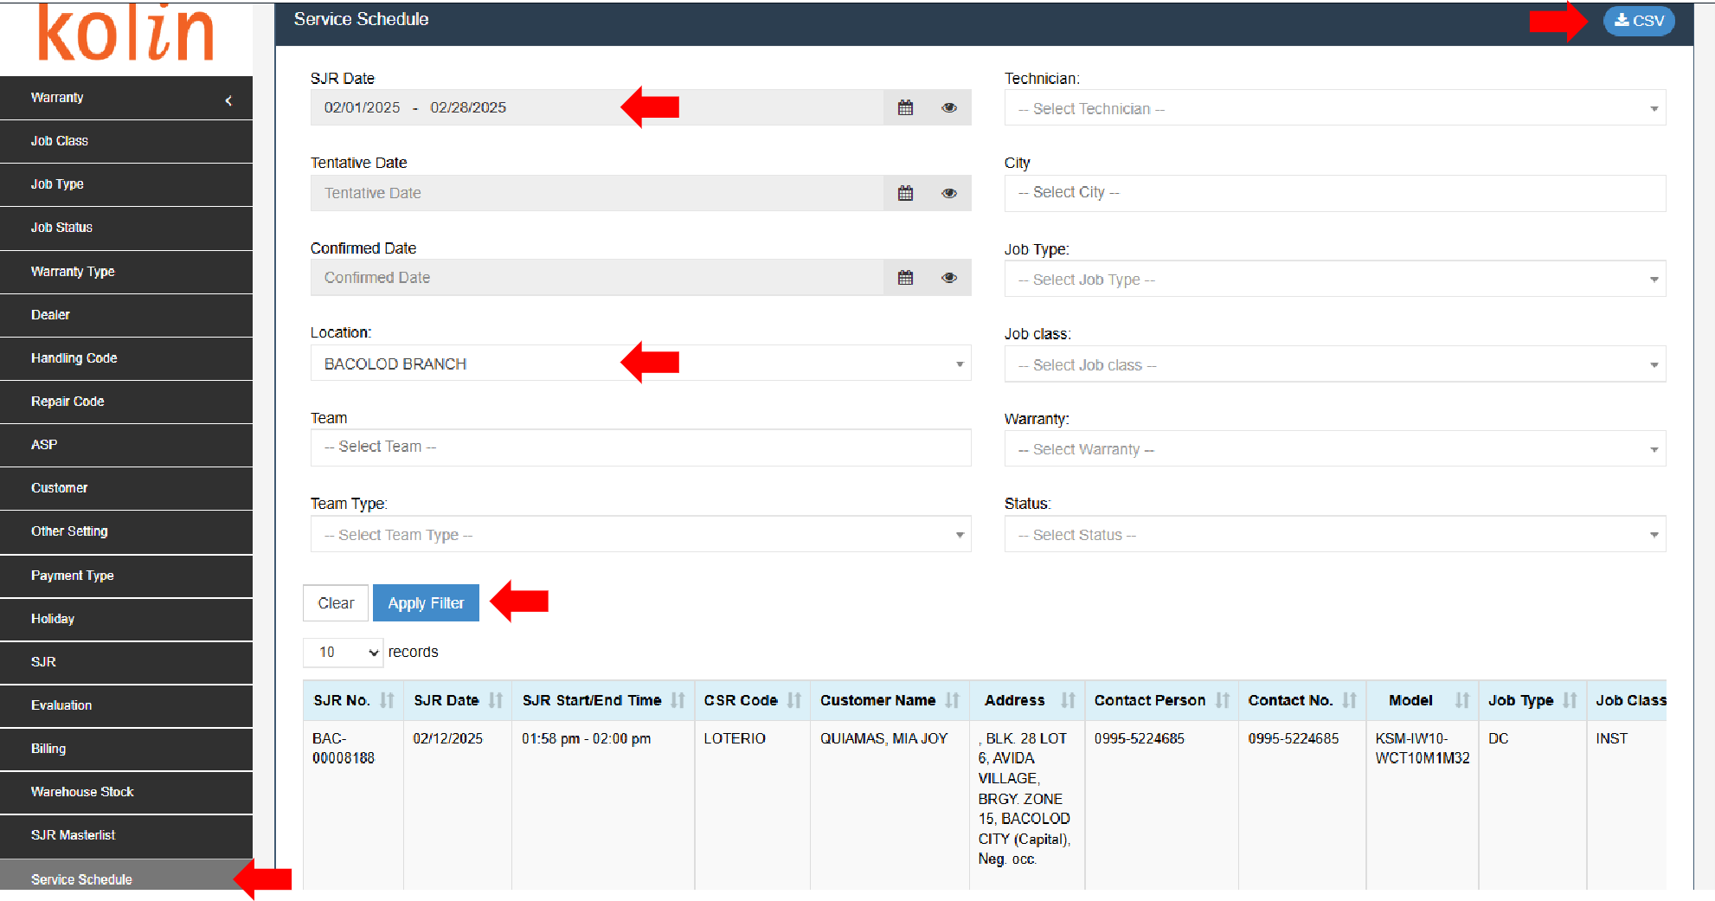
- Open File. Sort by Team Type. Remove In House.
- Sort by Status. Remove any status other than Evaluation.
- Copy SJR Code for Evaluation.
- Open Quadrant. Go to Evaluation.
- Paste SJR Code. Search. Open SJRs.
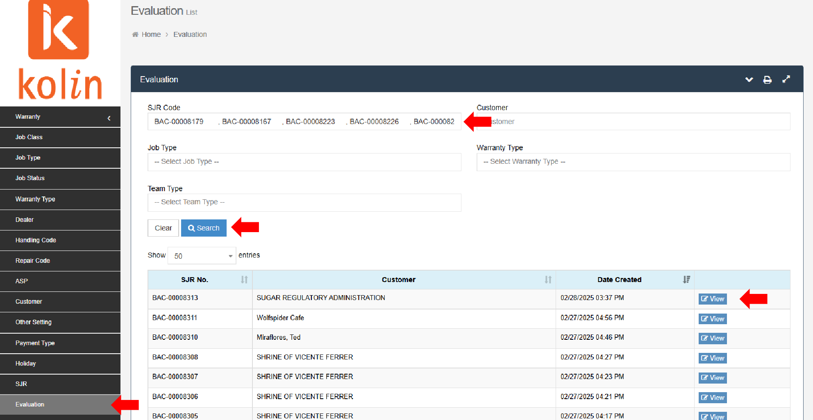
- Evaluate SJRs.
- Check details.
- Once evaluated, proceed to Billing.

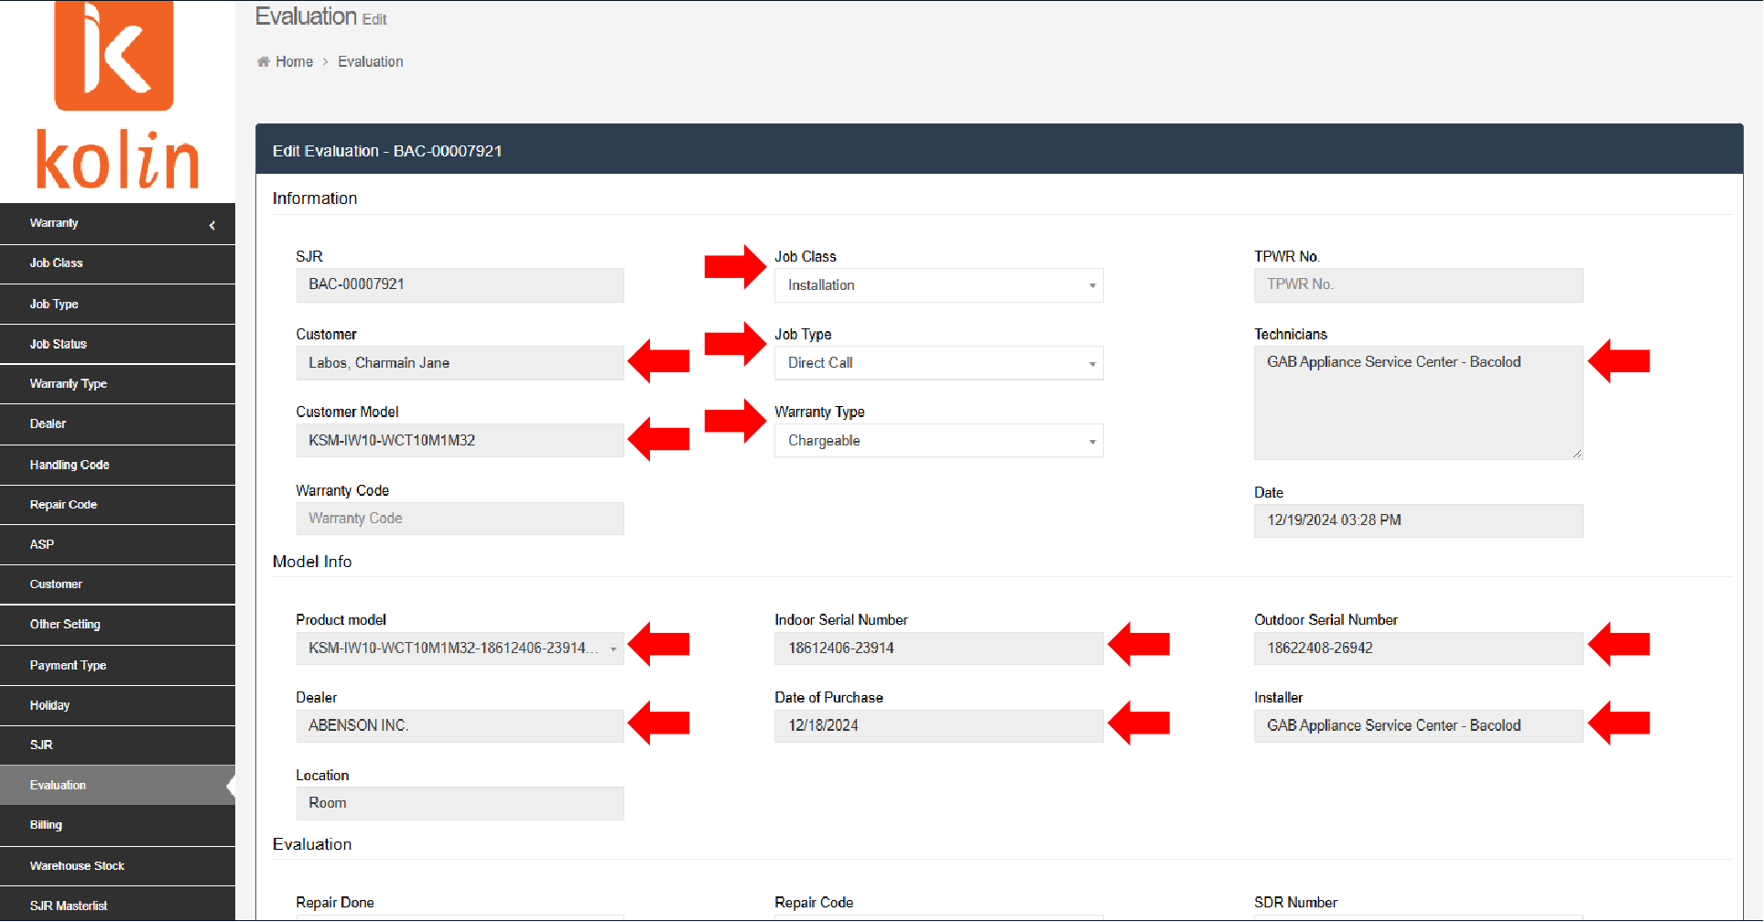
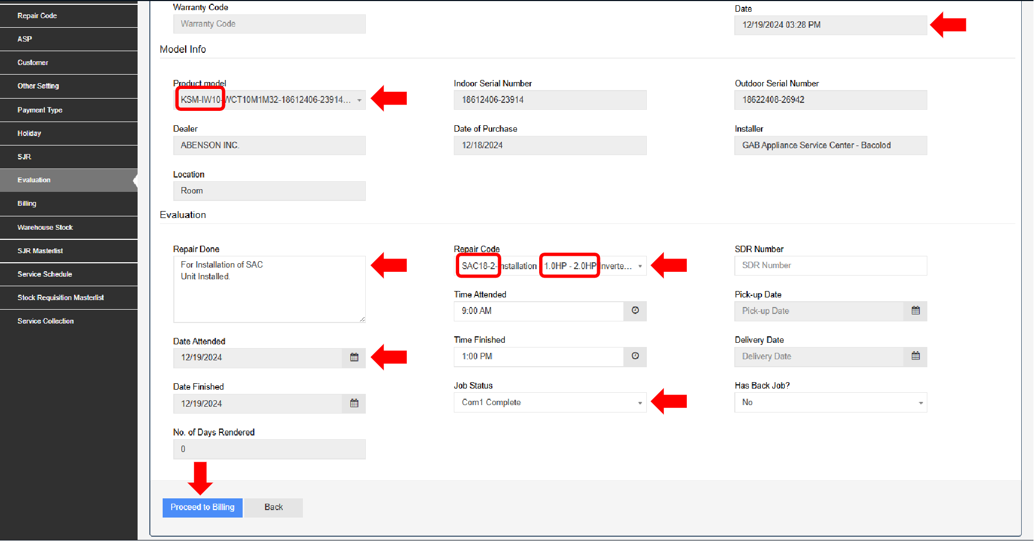

SJR BILLING
- Go to Billing.
- Paste SJR Code. Search. Open SJRs.
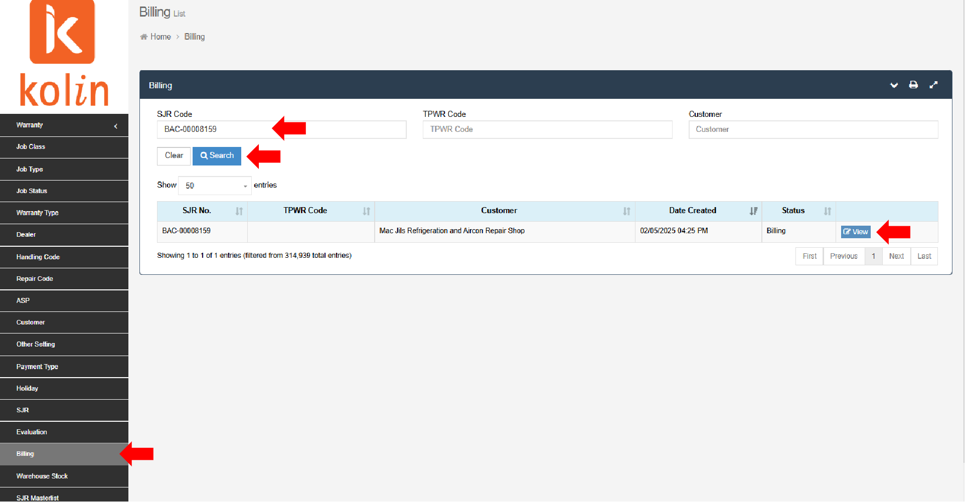
- Bill SJRs.
How to bill SJR:
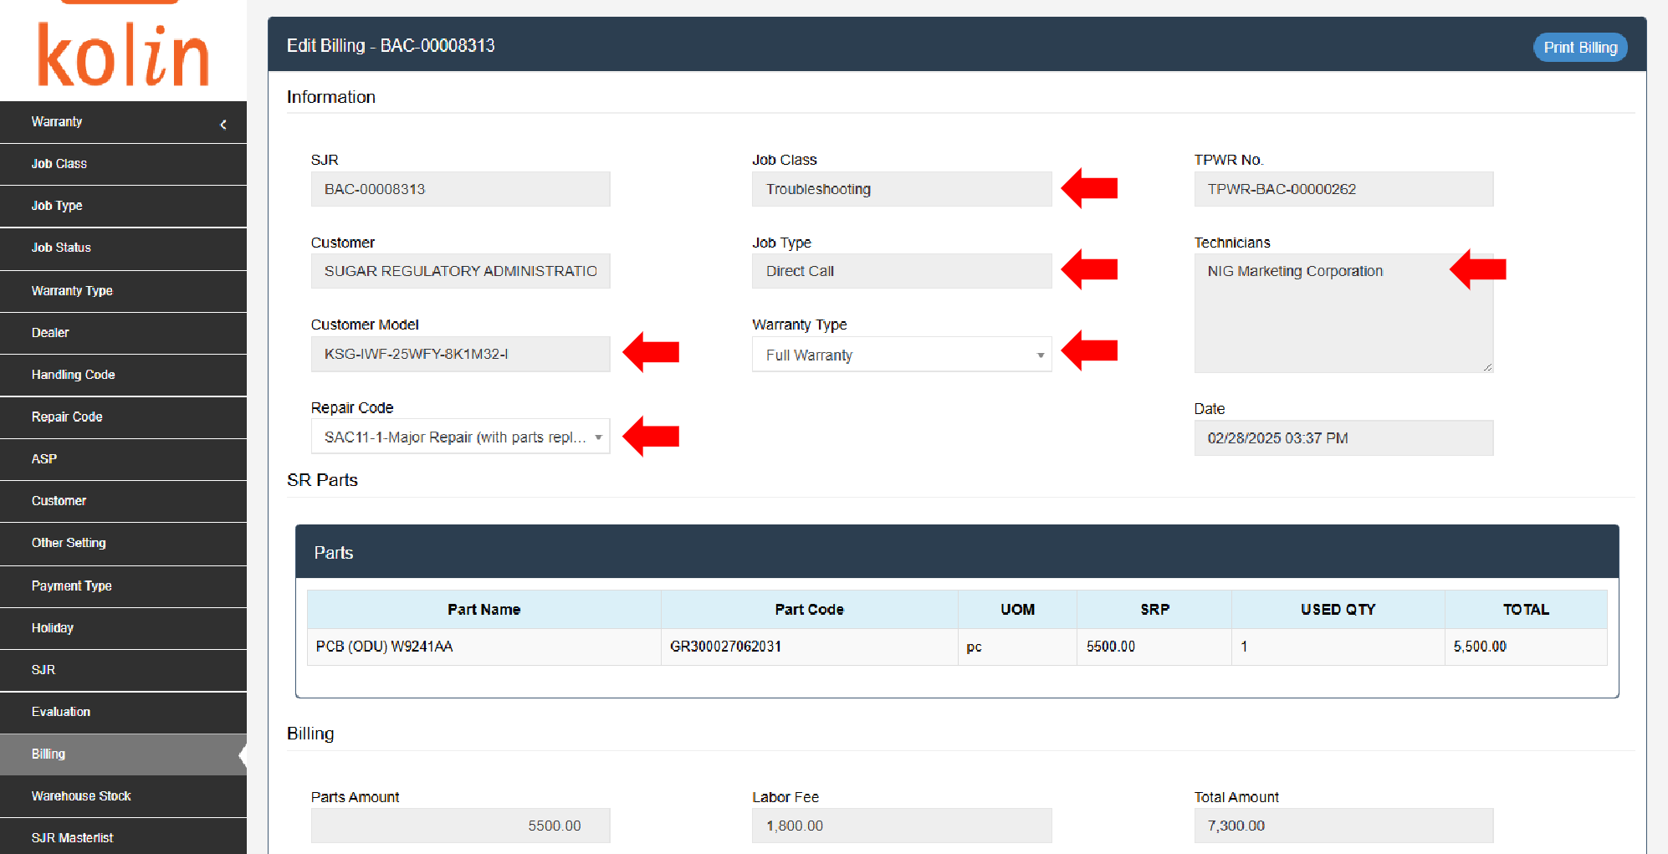
- Check details.

- Add Payment. Select appropriate Payment Type. Input amount.
- Payment Type for Installation
- Installation Record
- If with Processing Fee - Processing Fee
- Payment Type for Troubleshooting/General Cleaning
- Full Warranty - Full Warranty
- Chargeable - Relayed Job
- Chargeable with Parts - Labor Fee Collected by ASP (Labor Fee closing only)
- Parts Warranty - Parts Warranty for Parts, Labor Fee Collected by ASP for Labor
- Labor Warranty - Labor Warranty
- Labor Warranty with Parts - Labor Warranty (Labor Fee closing only)
- Payment Type for Sale of Parts
- Cash/Check
- If with Discount - Discount (20% for ASPs/Dealers)
- If with EWT -EWT
- Double check if all details are correct. Proceed to SAVE. Billed.
