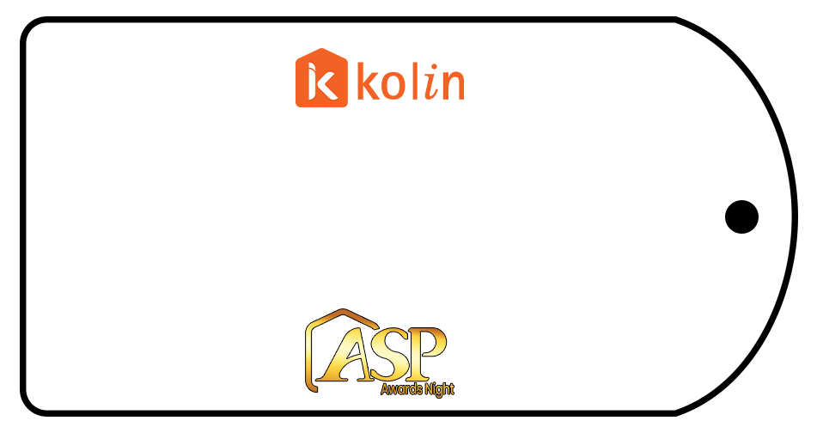
AIRCARE

GNASIT

TOP PREMIER

REYAIRE

AEQUUS

WINTERCRIB

HSB

AIREPUBLIC

LBR

JDL

R.ACOSTA

MJRC

CARCILLAR

ASHCOL

1ST QUAD

ALPINE

POWER AIRE

POLARIS

K42

ENTROPY

ENTHALPHY

ASERCO

RKH

RPMA

NVFS

MERG-AIRE

ADAM

RLT

RJD

RB HOME

ALDAYA

M.E.R.C

SHERPOL

J4L

DGREEC

ESTINOR

MAF REF

AGD

GODSPEED

DREAMCOOL

SERCON

LOVE

ZGP

PAR

ABYR

VRR

RTD

PURECOOL

ICOOL

FRJ

ESCOOL

ENVIRO

ECOLEON

DRETRE

DML

COOLING INSTINCT
ARACOOL

APM11

AIR MASTER

KENGIE

AIR BREEZE

WHITEFROST

RCC

POWERTECH

KLEIN & JUSTIN

CENILA

AIRKHOFRIGUS

TM LUZON

SURECOOL

SERVPRO

ROLLIE

ON-COOL

COOLTRONICS

EMAN

CHERATECH

BEA

ALFATECH

AIRCO SAVER

MARISON

NITZDAVID

MT. SINAI

MBJ

DENLIN

COLD AVENUE

KING’S AIRE

JAAES

BARMEN

SURE SHOT

ROY
RNM

MSM

KING AIRE

J-MAX

JJR

JERRICO

JEFF

5JC

VPR

MEGA CALAPAN

REY-SON

LGP

GLT

L&E

CYLINDER

OLTEK

COLDZONE

AL-ELECTRO

WINTER COOL

ASAST

NEW WHITELINES

ROMBLON

VIRAC AIRCON

