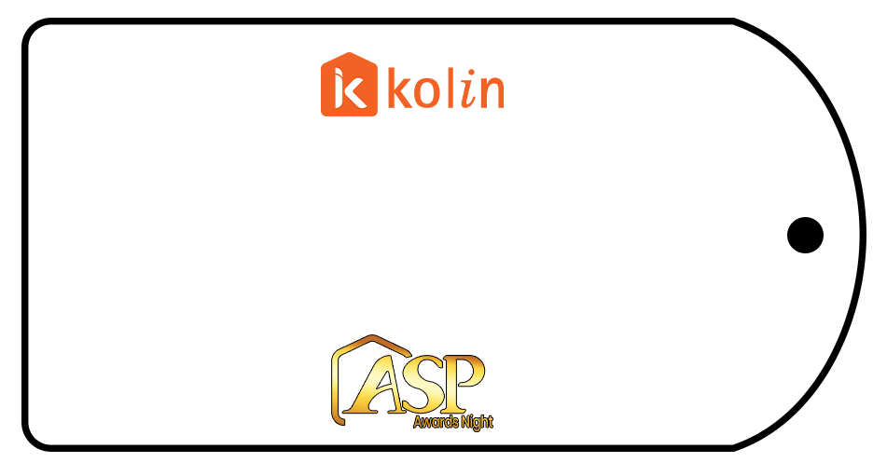

DL ELECTRONICS
RL MANAOAT

RSK
ROMERZAN

MEGAWORK

SOLIS

CAPITAL

TARLAC NORTHERN

FORONDAS

RIVERDALE

SUNSTAR
GREEN AIR

DGMC

ST. JOSEPH

NEW DANS
NDJ’S

SENTINE

PRETTY COOL

MAGIC SWITCH
JMD

SPEED COOL

MFD

ALAP

COOL AIDE

CENTRAL SUMMIT
3K AIRCOOL

MHIKE’S

NADGIE AIR

AVALANCHE

OE APPLIANCES
88 SMART COOL

EDS79
MAC AIRE

YANIT

RICKZON

JNGJ

