BUSINESS PLAN MATRIX UPDATE
1st QUARTER
FINANCE DEPARTMENT
(SERVICE ACCOUNTING)
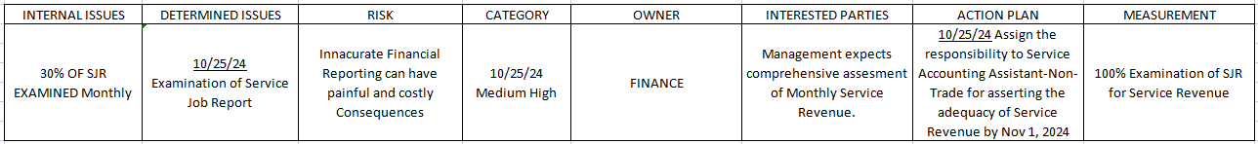
The table above presents the Business Plan Matrix for the Service Accounting Department. It outlines identified issues and potential risks, along with corresponding action plans designed to address and mitigate these challenges proactively.
The data presented herein details the Service Job Report (SJR) activity for the months of October, November, December 2024,and January, February and March 2025. This report outlines the total number of SJR’s generated each month, the quantity of SJR’s examined versus those not yet examined, and the corresponding monthly examination percentage. The data indicates a declining trend in the total number of Service Job Reports Examined. Furthermore, the Department has not achieved the targeted 100% examination rate for total SJR’s across the six month period.

Impact and Probability of Continued Trend:
If the current trend of not achieving 100% SJR examination continues, the following impacts are probable:
- Increased Backlog: A growing number of unexamined SJR’s will likely accumulate, leading to delays in crucial processes such as performance analysis, and identification of recurring service issues.
- Delayed Financial Reporting: Untimely examination of SJR’s can impede the generation of accurate and timely financial reports, potentially affecting strategic decision-making.
- Reduced Efficiency: The inability to process all SJR’s promptly can negatively impact the overall efficiency of the Service Accounting Department and potentially downstream departments.
- Compromised Data Integrity: Delays in examination may increase the risk of errors or omissions in the data, affecting the reliability of service performance metrics.
- Potential Non-Compliance: Failure to adhere to the business plan matrix's target of 100% examination could indicate a deviation from established operational standards and potentially lead to scrutiny.
Proposed Action Plan:
To ensure the achievement of the targeted 100% examination of Service Job Reports as outlined in the business plan matrix, the Service Accounting Department proposes the following action plan:
- Streamline SJR Closure Process: Implement a defined time-frame of seven (7) business days for the closure of Service Job Reports following their evaluation by the Service Department.
- Enhance Coordination: Establish a clear protocol for proactive coordination with the respective coordinators/staff responsible for generating SJRs to ensure timely closure. This includes regular communication and follow-ups.
- Prioritize Critical SJRs: Implement a system to prioritize the processing of Service Job Reports related to warranty claims, installations with referrals, and other urgent claims to ensure timely resolution.
- Daily Monitoring and Reporting: Implement a system for daily monitoring of the SJR examination status to identify and address any bottlenecks promptly. Regular reports on the progress towards the 100% target should be generated and reviewed by Service Accounting Assistant (Non-trade Inventory).
- Create Guidelines and Policies:
- Develop clear guidelines outlining the responsibilities and timelines for SJR processing at each stage, from generation to examination and closure.
- Establish formal policies regarding the handling of pending SJRs, escalation procedures for delays, and the required documentation for each type of SJR.
- Document the streamlined SJR closure process and communication protocols to ensure consistency and accountability.
- These guidelines and policies are effective on May 1, 2025, a month after they were created.
- Proposed to lower risk category from Medium to Low.
- Due to low probability.
The Service Accounting Department is committed to addressing these issues and will diligently monitor progress to ensure adherence to the company's standard policies and the achievement of departmental goals.

Prepared by: Noted by:

Richell V. Hicban Thaddeus George C. Roman
Service Accounting Supervisor Accounting Assistant Manager

