BUSINESS PLAN MATRIX UPDATE
2nd Quater
FINANCE DEPARTMENT
(SERVICE ACCOUNTING)

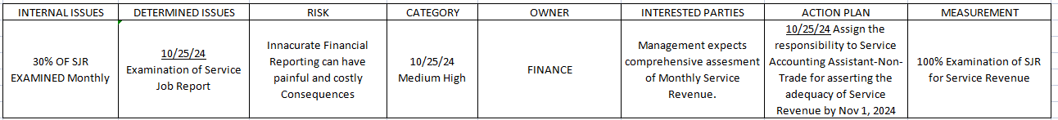
The table above presents the Business Plan Matrix for the Service Accounting Department. It outlines identified issues and potential risks, along with corresponding action plans designed to address and mitigate these challenges proactively.

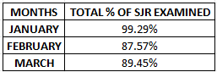
The data presented above shows the percentage of Service Job Report examined for the Month of January to March 2025. This data shows the declining trend of examining and closing of Service Job Report for the three consecutive months. With this declining trend the Service Accounting Department implement action plan on how to achieve the 100% of examination of Service Job Report in each month. The following action plan made listed below:
- Create memo on the standard policies and guidelines for Service Job Report Liquidation refer to memo FIN-000-25-4-14.
- Comprehensive monitoring and follow-up to Service Department to ensure to achieve the department goal in achieving the 100% of examination of Service Job Report .

With this action plan made by the Service Accounting Department and strict compliance to the companies goal the department is now achieving the 100% examination of Service Job Report from April to June 2025. See the data below:
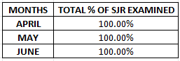
To ensure to continue this strict compliance to achieve the Department goal in achieving 100% examination of Service Job Report every month the Service Accounting Department will continue to strictly monitor and communicate to Service Department.

Prepared by: Noted by:

RIchell V. Hicban Thaddeus George C. Roman
Service Accounting Supervisor Accounting Assistant Manager

