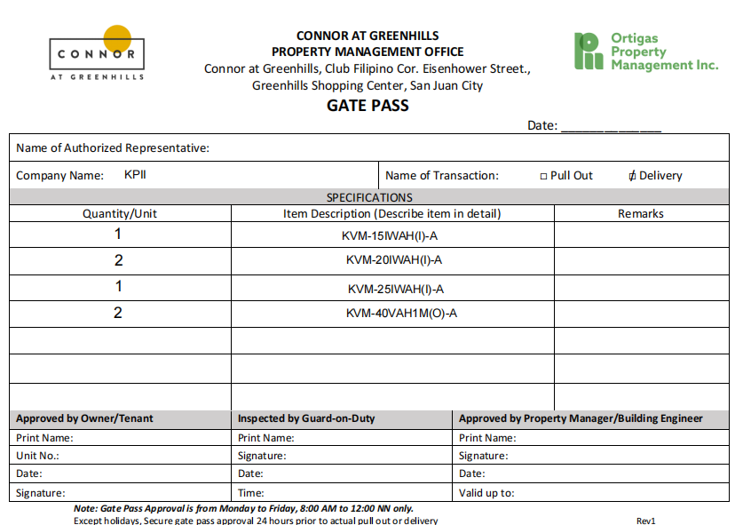
DRIVER: JOVEN ENTIS - HELPER: JEFFREY SEBASTIAN (09479757209) AKATSY LOGISTICS SERVICE - PLATE # NFS 2453 (4W CLOSED VAN)

)

02/02/2026

