AIR COOLER WITH PURIFIER SCRIPT

INTRODUCTION:

Showcasing of Air Cooler with Purifier (Videos to Use):
- Video 1 - Front View of Air Cooler with Purifier
- Video 2 - Left Side of Air Cooler with Purifier (i cut na lang naisama back side)
- Video 3 - Back Side of Air Cooler with Purifier
- Video 4 - Right Side of Air Cooler with Purifier
- Video 4 Option 2 - Right Side of Air Cooler with Purifier
- Video 1 to 2 Transition (Optional)
- Video 2 to 3 Transition (Optional)
- Video 3 to 4 Transition (Optional)

Script:
- Kolin’s Air Cooler offers a modern and efficient way to keep indoor spaces cool. By utilizing the natural process of evaporation, it provides a cost-effective and environmentally friendly alternative to conventional air conditioning systems. Ideal for areas ranging from 20 to 30 square meters, it’s well-suited for homes, offices, workshops, and similar spaces.

- Kolin’s Air Cooler operates using a “Direct Evaporative” cooling and humidification system. It not only provides effective cooling but also helps maintain optimal air moisture levels for a more comfortable environment.

Presenting the Air Cooler with Purifier’s Features and Parts
Pictures to Use:
- Picture of Remote Control (Air Cooler)
- Air Cooler Control Panel
- Picture of Air Cooler (Front and Back Portion) (Nasa may camera po ng Marketing)

Use this as Reference kung pano ipapakita ung mga parts (Ganitong labeling sana)

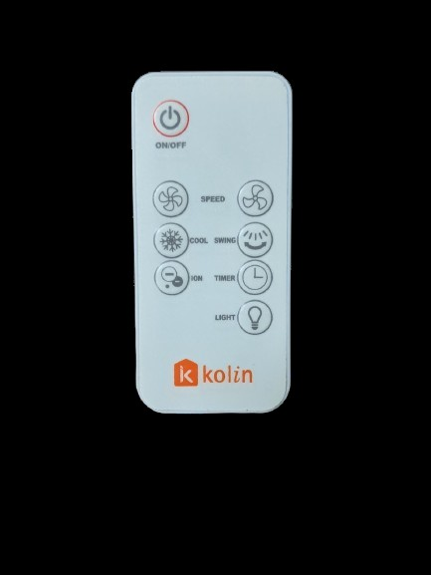
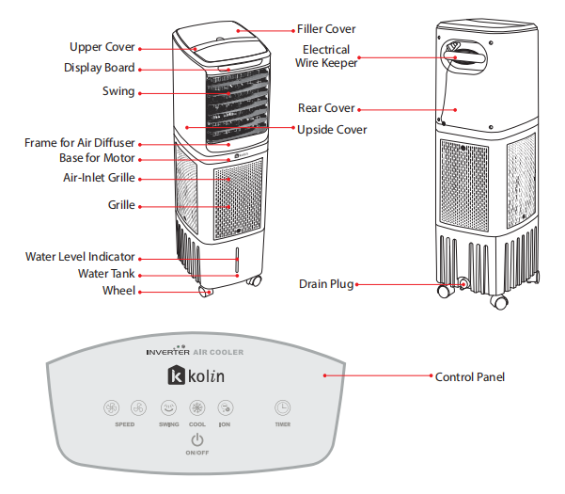

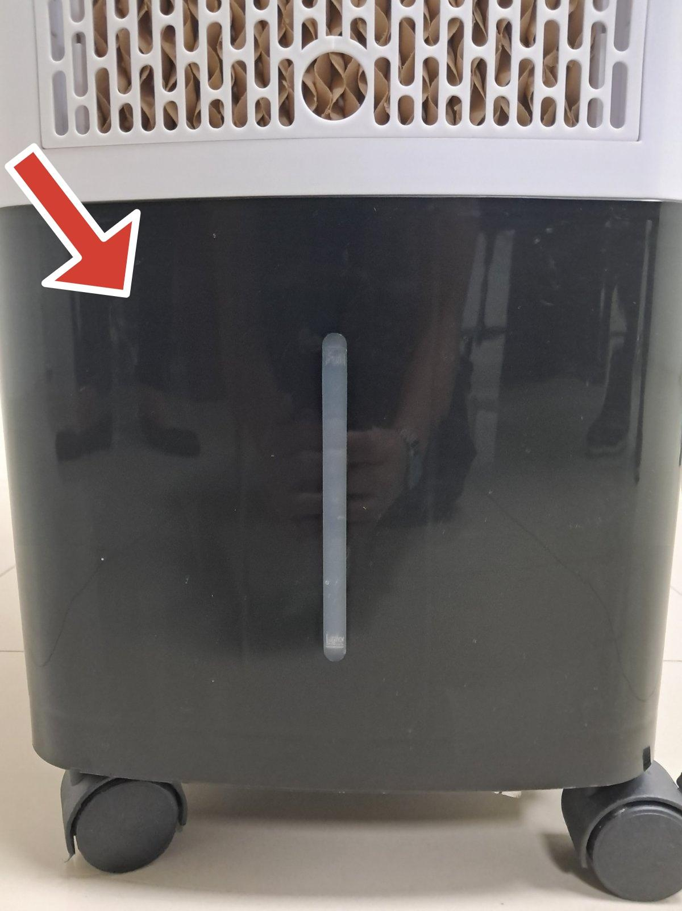
- Water Tank - The Air Cooler features a water tank that holds up to 13 Liters of Water. (Picture of Water Tank)

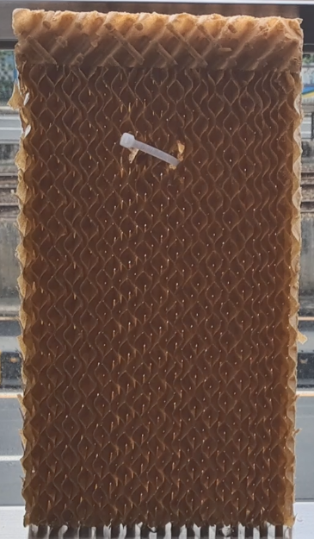
- Cooling Pads - The Cooling Pads absorb water from the tank and use the natural process of evaporation to cool the surrounding air effectively.

(Picture of Cooling Pads)

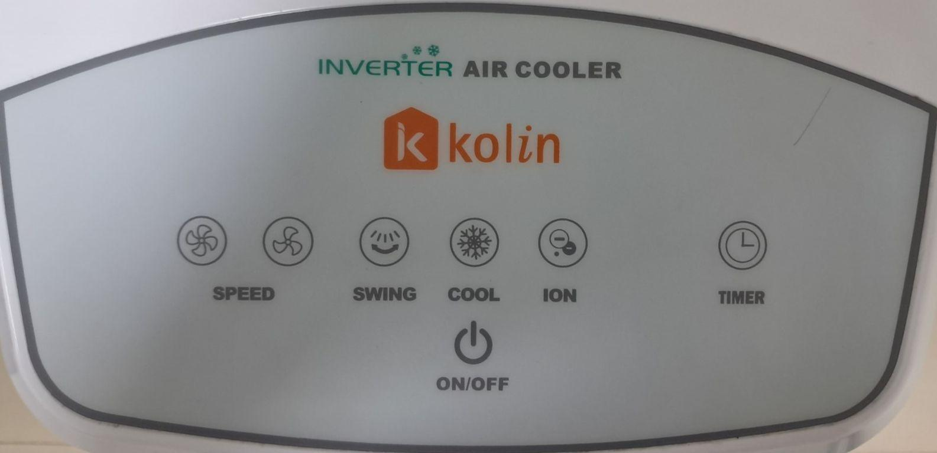
- Control Panel - The Air Cooler features a control panel that allows you to adjust the fan speed, cooling level, and timer settings. (Picture of control panel)

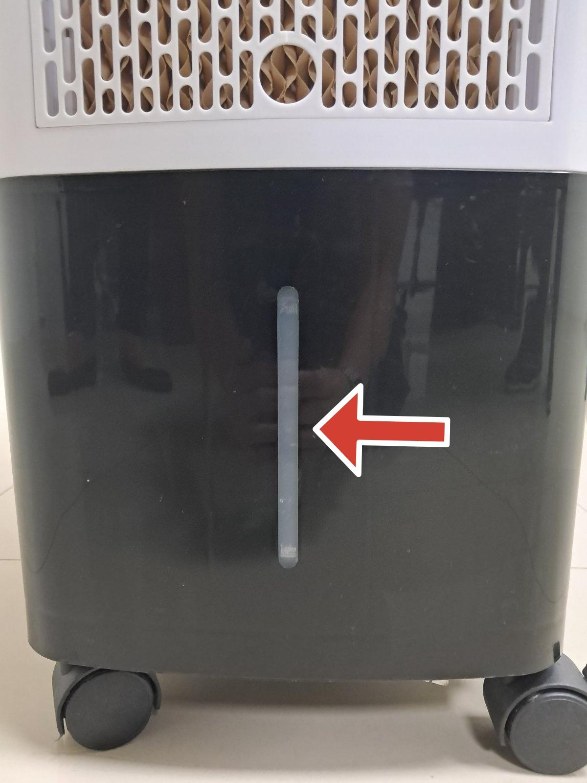
- Water Level Indicator - is a built-in feature that allows users to monitor the water level within the product. (Picture of Water Level Indicator)

- Anion Generator - is a device that produces negatively charged ions, known as anions, which are often associated with air purification. These ions can help remove pollutants, allergens, and airborne particles, contributing to cleaner and fresher air.
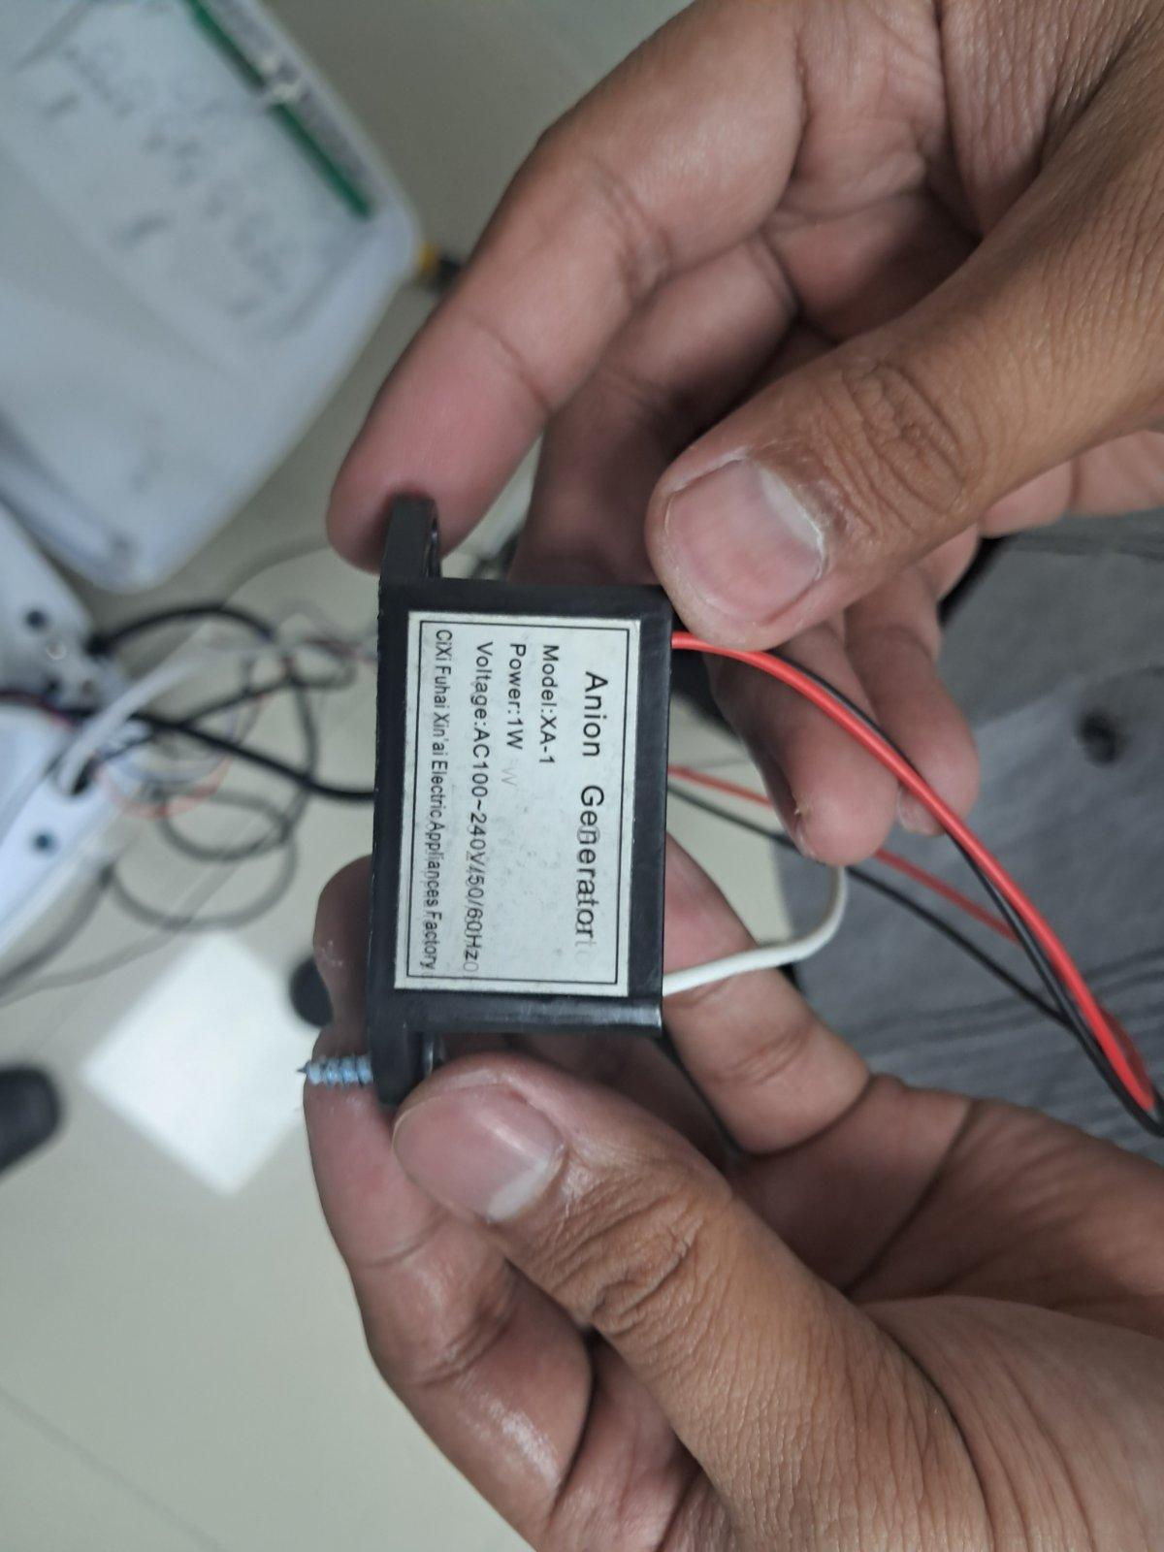

(Picture of Anion Generator)

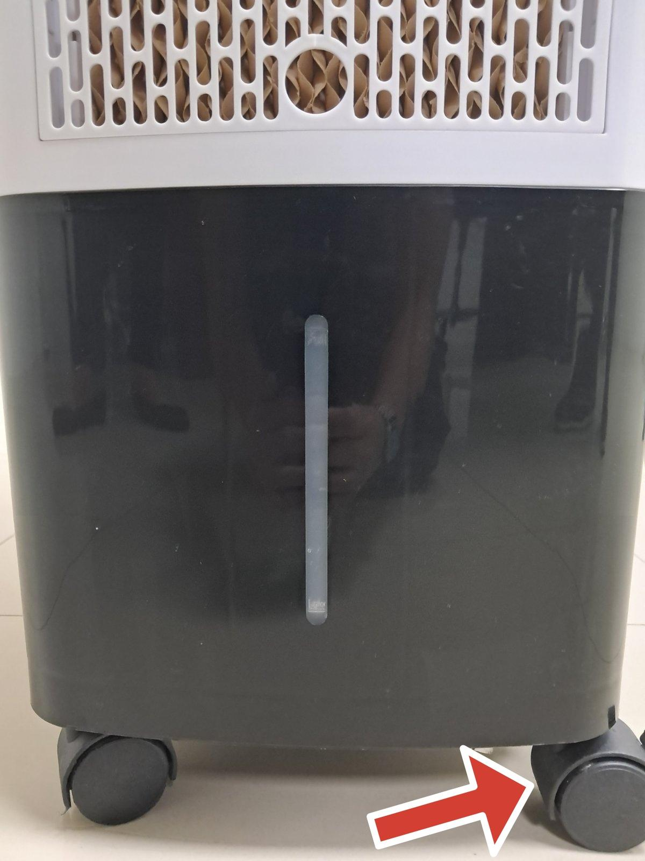
- Caster Wheels - The air cooler is equipped with caster wheels that make it easy to move around.

(Picture of Caster Wheels)

Key Benefits of Air Cooler with Purifier: (EDIT - kahit cliparts na lang related sa mga benefits)

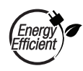 Energy Efficient - it offers efficient cooling without using a lot of energy, which lowers your electricity expense.

ECO - Friendly - It is a more environmentally friendly choice for your cooling area since it does not utilize any dangerous chemicals or refrigerants.

Portable - Because of its caster wheels, it is portable, making it a flexible and practical cooling option for any area.

 Easy to Use - It has easy-to-use controls and settings that let you change the comfort level to your preferred degree.

 Health Benefits - By purifying and humidifying the air, it lowers the risk of allergies, asthma, and other respiratory issues, improving indoor air quality.

Before using the Air Cooler with Purifier, follow these safety instructions to help prevent accidents or hazards using your Air Cooler. ]

Editing Suggestion (Kahit Cliparts na lang ulit related sa mga Safety Instruction)
 WARNING: For Personal Safety

- Make sure the power wire is free of damage before plugging in the air cooler. Do not use the air cooler if the cord is damaged. For prompt assistance, call our Authorized Service Center or Kolin Hotline.

- Always use a power supply that corresponds to the voltage, frequency, and rating listed on the product identification label when operating the air cooler. Reference:

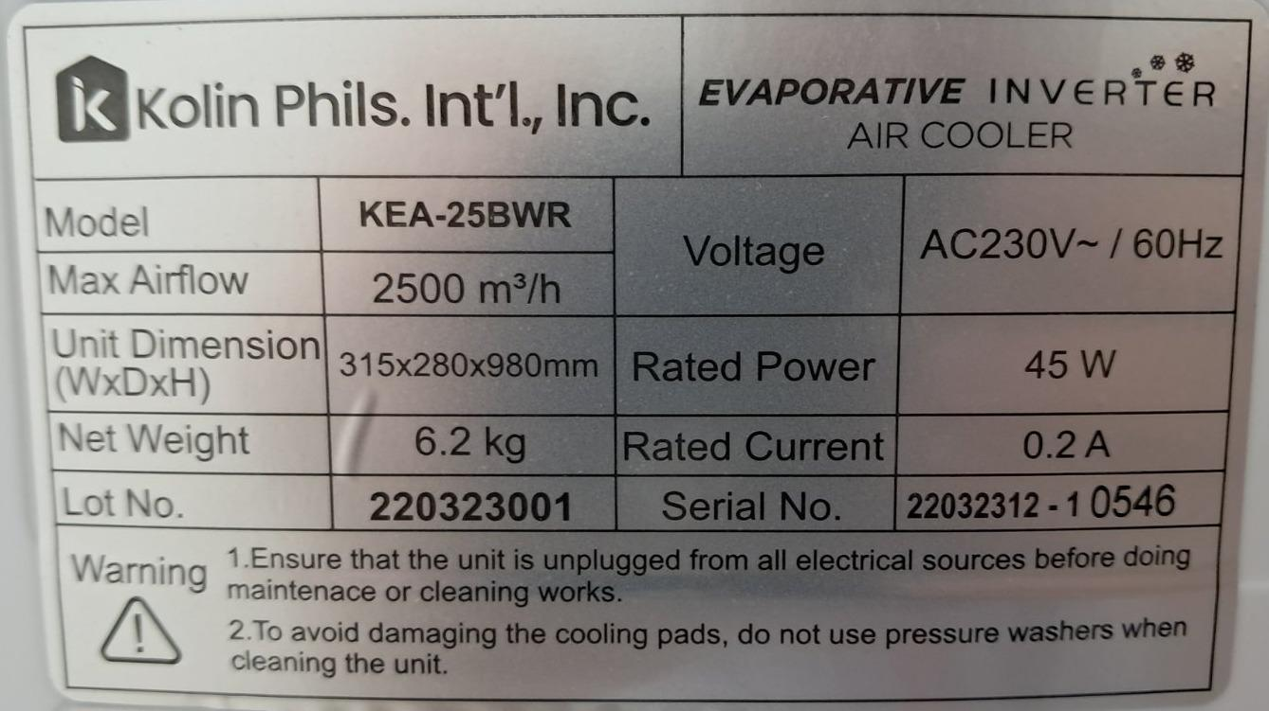

- Keep the Air Cooler away from children and pets. Make sure kids are always under supervision when they are around the unit.

- Avoid operating the Air Cooler away from water and other liquids to prevent electrical shock.

- Keep the Air Cooler away from water and other liquids to prevent electrical shock

- Always unplug the Air Cooler before cleaning or performing maintenance

- Avoid using the Air Cooler if it has been dropped, damaged, or exposed to extreme temperatures.

Caution: For Installation, Use and Maintenance of Air Cooler

- After adding water, do not tilt, collide, lay, or move the air cooler to any position that may cause water to overflow. Do not overturn the Air Cooler.

- In high humidity conditions, it is advisable to use the “Wind Mode” instead of the cool mode, as the latter has a humidifying effect.

- Always disconnect the Air Cooler’s power supply before moving it from one location to another.

- Remember to unplug the Air Cooler when not in use.

- Avoid placing the Air Cooler close to walls or window curtains, as this may block the airflow.

- Refrain from inserting any objects or body parts into the air cooler while it is operating.
- Clean the Air Cooler with a damp cloth, but do not flush it with water directly.

- Avoid placing the Air Cooler near heat sources or open flames.

- Only qualified professionals should perform repairs on the Air Cooler.

 Do Not : This Symbol indicates actions that must never be performed.

- Do not attempt to repair or disassemble the air cooler yourself, as this can be dangerous and will void the warranty.

- Do not cover the guard or operate the air cooler too close to curtains, furniture, or other subjects.

- Do not place any objects on top of the air cooler.

- Do not obstruct the air outlet and provide at least 1 meter of space in front and behind the air cooler.

- Do not use the air cooler in environments with high humidity or excessive moisture.
Air Cooler Manual Operation and Remote Operation:

CONCEPT: Same with Coffee Tea Bar na dual screen presenting yung manual operation and remote operation ng Air Cooler

- Adding Water to the Air Cooler
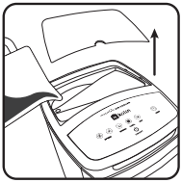
- Open the water inlet on the top cover and pour water into it.

- Avoid splashing water onto the motor to prevent damage to electrical components. (Video to Use: Video 5 - Adding Water)

- Ensure that the water level is below the maximum level. Refer to the water indicator at the front of the tank to prevent overflowing.

NOTE:
- Only use clean water to fill up the air cooler (kahit clip art na lang)
- Before adding water, make sure that the unit is turned off (kahit clip art na lang)

- Powering Up AC Cooler
- Plug it into an AC Outlet, after plugging it in, you will hear a beep sound indicating that the unit is in standby mode. (Video 5 - Powering Up Air Cooler)

- Turning On the Air Cooler
- Turn on the Air Cooler by pressing the ON/OFF Button on the control panel or remote controller. (Video 5 - Powering Up the Air Cooler - Pa cut na lang sa part na bubuksan na yung Air Cooler) (Video 6 - Remote Power Button)

- The Default Setting is “Wind Mode” to switch to “COOL” mode, press the corresponding button on the panel or remote controller.

- If you press the Cool Button on the control panel, and the Cool Icon on the Display Panel is blinking, that means there is not enough water in the tank.

- Ensure there is enough water in the tank to use the COOL Mode.

(Video to Use: Manual Cool Button, Remote Cool Button)

- Adjusting Fan Speed
- Select your desired fan speed by pressing the speed button on the LED control panel or remote controller.
- There are “9” different speed levels, with level 9 being the highest.
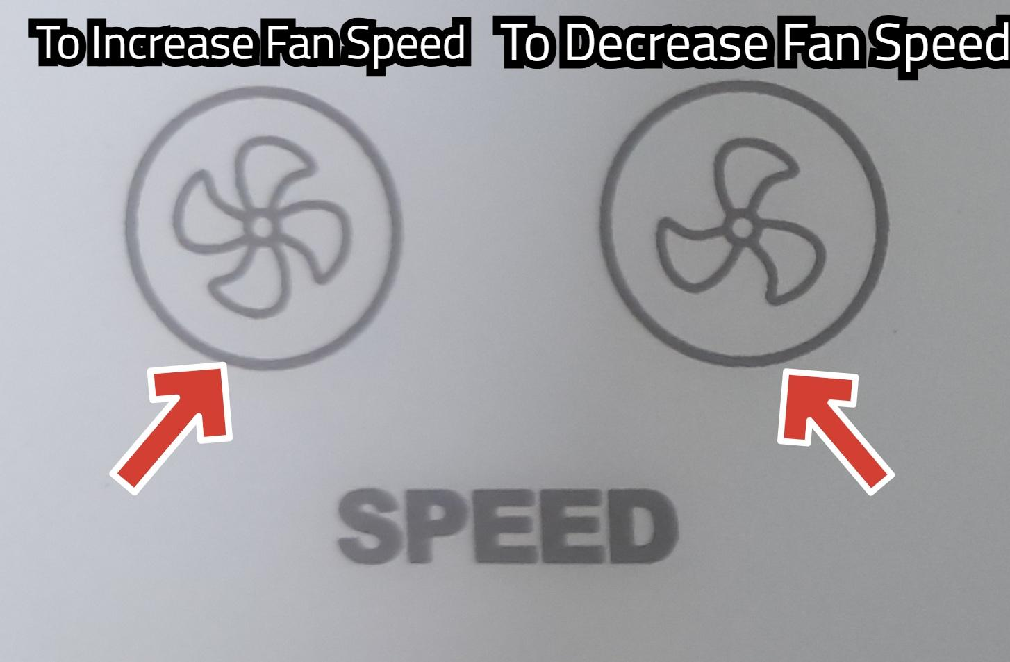
(Video 7 - Remote Adjusting Fan Speed, ipakita na lang yung picture ng Fan speed sa manual nawawala ung video use this picture as reference sa manual) NOTE: Kung mas maeedit pa yung picture much better.

- Using the Oscillation Feature
- To enable oscillation, press the swing button on the control panel or remote controller. This will move the vertical louvers automatically from left to right.
- NOTE: Adjust the horizontal louvers “Manually” to direct the air way from you if desired.

- (Video 8 - Oscillation Feature, Video 9 - Remote Oscillation Feature)

- Activating the Ion Feature
- Press the ion button on the control panel or remote controller to activate the air purifying feature. This generates negatively charged ions (anions) to help remove pollutants, allergens, and airborne particles, contributing to cleaner and fresher air.

- (Video 10 - Manual Ion Feature, Video 11 - Remote Ion Feature)

- Adding Ice for Extra Cooling
- You can add ice cubes for extra cooling, but be careful not to overflow the water tank.

- Turn off your air cooler and unplug it. (Video 12 - Turn off Air Cooler)
- Open the front air inlet grille over. (Video 13 - Removing of Inlet Grille Cover and Cooling Pads)
- Remove the stick lock for the cooling pads. (Video 13 - Removing of Inlet Grille Cover and Cooling Pads)
- Remove the cooling pad by gently pulling the wire until the pad pops out. (Video 13 - Removing of Inlet Grille Cover and Cooling Pads)
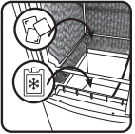
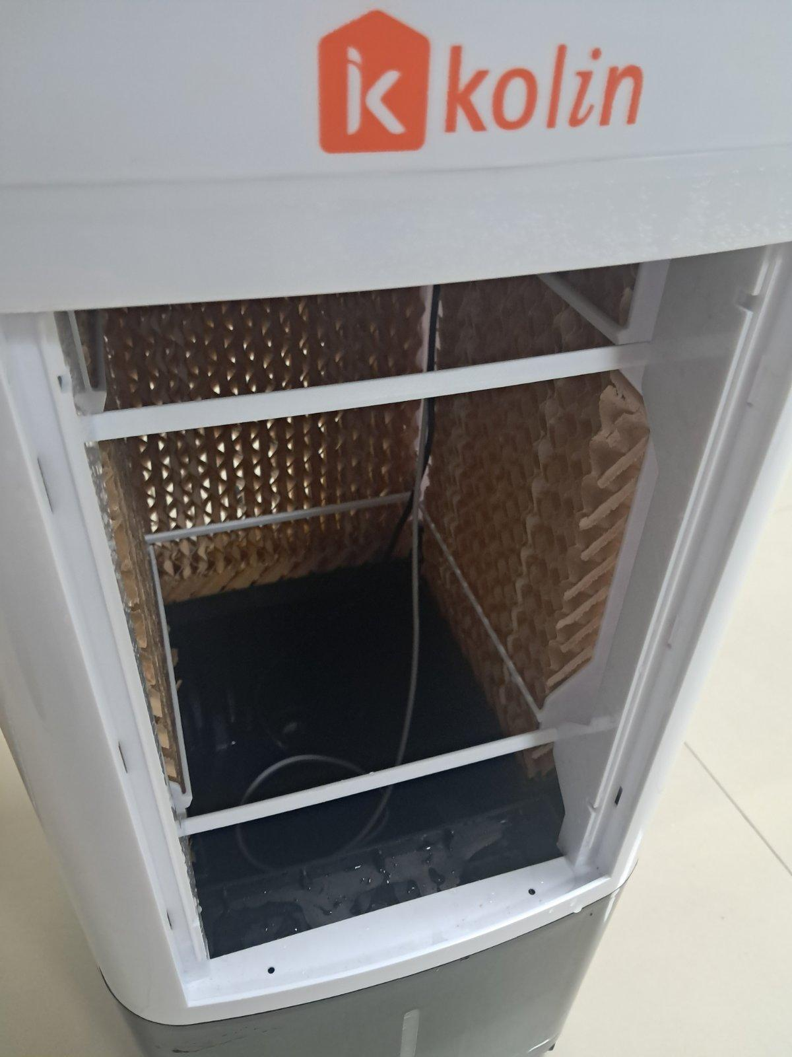
- Add Ice without overflowing, paying attention to the water tank sensors. You can use tube ice, blocks of ice, or ice packs (NOTE: Kahit clip art na lang po dito ng mga ice) (Use this photo and manual as reference)

- Setting the Timer
- Pressing the “Timer” button on the control panel or remote controller to set a specific amount of time before the unit turns off. The timer can be set from 1 to 9 hours, or to non-timer mode. The indicator will turn off in non-timer mode.
- (Video 14 - Manual Setting of Timer & Video 15 - Remote Setting the Timer)

- Low Water Level Indicator
- Indication that the water level is getting low occurs when the fan speed drops to low and the cool icon on the front of the display board will start blinking. It is recommended to add water as soon as you experience a sudden drop in fan speed to maintain its cooling effect.

- (Video 17 - Low Level Water Indicator)

- Additional Feature: An additional Feature that can be found on the remote controller only of the Air Cooler is the “Light” Button which turns on and off the light on each icon found on the Display Panel. (Video 16: Remote Blinking of Light)

- Turning Off the Air Cooler
- When you are done using the air cooler, turn off by pressing the ON/OFF button on the control panel or remote controller.

- (Ref: Video 12 - Turning off Air Cooler)
ENDING:

We are confident that our evaporative Air Cooler will provide you reliable and effective cooling performance for many years to come!

Thank you for choosing Kolin as your trusted brand!

CLEANING AND MAINTENANCE OF AIR COOLER WITH PURIFIER
.

Here are the possible materials that you will need for cleaning the Air Cooler.
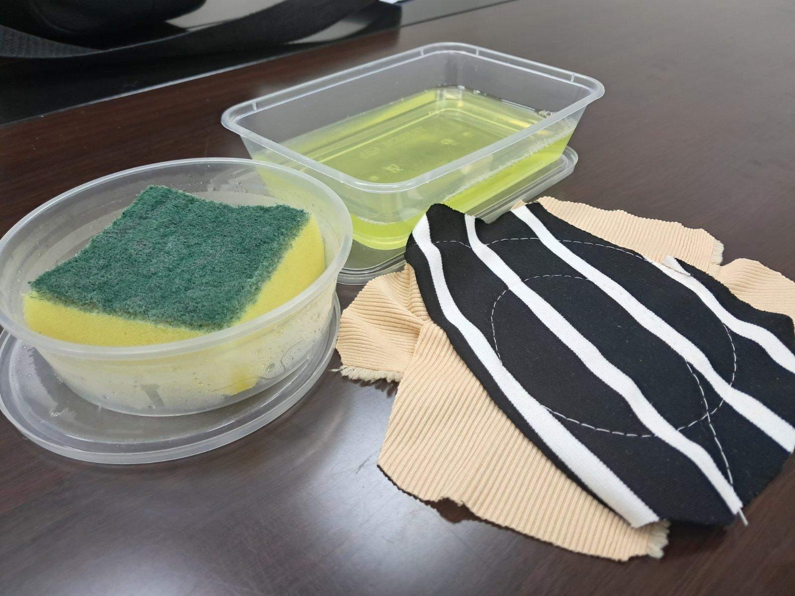

(Sponge, Soap Solution/Washing Liquid, & Soft Cloth)

CLEANING THE WATER TANK

- Turn Off the Power & Unplug
Before performing any maintenance or cleaning on the machine, unplug and turn off the power to prevent accidents.
(Video 12 - Turning off Air Cooler)

- Remove panels and cooling pads
Take out the air inlet grille cover, stick lock and cooling pads.
(Video 18 - Remove Panels and Cooling Pads)

- Drain Water out of the Air Cooler
Open the drain plug if the portable air cooler has one. If the water tank is detachable. It will be an easy job.
(Video 19 - Drain Water out of the Air Cooler)

- Brush out the inside of the Cooler and Clean with Water and Mild Soap
- Use a soft cloth or sponge to sweep the inside of the air cooler. Remove the water tank and clean it with a mild soap solution.

- Rinse it thoroughly with clean water and wipe it dry with clean cloth.

(Video 20 - Clean with water and mild soap)
(Video 21 - Wash it with clean water)

CLEANING THE COOL PAD

- Soak the Pads
Submerge or wash the cooling pads with water for 30 to 60 seconds.
AVOID: Avoid using strong detergents as they may damage the pads.

(Video 22 - Cleaning the Cooling Pad)

- Air Dry the Pads
After the cooling pads have been thoroughly soaked, rinse them off and set aside to air dry completely before reinstalling them in the unit.

(Video 23 - Air Dry the Cooling Pad)

CLEANING OUTSIDE OF THE COOLER

Turn off the unit and wipe down the outside with a damp cloth using only water. Do not use any harsh chemicals that may cause damage.

(Video 24 - Cleaning Outside Body of Air Cooler)
(Video 24-1, Video 24-2, & Video 24-3)

ENDING

Reminder: Always follow the manufacturer’s instructions and guidelines for cleaning and maintenance to ensure the longevity and proper functioning of your Air Cooler.

