AUTHORIZATION LETTER
11/08/2022

To whom it may concern;
I, Sybelle Anne Gabuyo am writing this letter to authorize to name the check of my back pay to Mr. Jake Bryan A. Trajeco.
Please see attached ID for verification.
Thank you for your assistance..

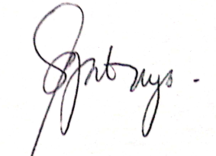
Yours,

Sybelle Anne Gabuyo

