Coffee Tea Bar Script/Flow
- Product Introduction
- Safety Precautions
- Product Features and Parts
- Installation and Usage Method
- Touch Panel and Remote
- Video Procedure
- Display Panel Indication
- Video Per Panel
- Standby / “OFF” State
- Proper Cleaning and Maintenance
- Important Safety Instructions
- To User
- Ending

Product Introduction
(VIDEO: SHOWCASING THE COFFEE TEA BAR)

Video to use:
- Video 1: Front View of Coffee Tea Bar (Option 1) or (Option 2) depends kung ano mas magandang kuha.

- Video 2: Left Side of Coffee Tea Bar (Option 1) or (Option 2) depends kung ano mas maganda kuha.

- Video 3: Back Side of Coffee Tea Bar

- Video 4: Right Side of Coffee Tea Bar (Option 1) or (Option 2) depends kung ano mas maganda kuha

CONCEPT/SUGGESTION: With the different views nung coffee tea bar ang suggested edit ko is paikot ung mangyayaring concept of showcasing the coffee tea bar diskarte na lang sa edit kung pano mas mapaganda ung pag showcase.
SCRIPT UNDER INTRODUCTION PART:
Kolin Philippines introduces its new innovative Coffee Tea Bar, the ultimate solution for all your beverage cravings.

(Note:Emphasize)
- With just a simple touch, you can indulge in refreshing cold water.
- Experience the pleasure of real boiling hot water at 100°C and benefit from the built-in insulation plate that keeps your hot beverages warm for longer periods.

The Coffee Tea Bar not only delivers exceptional functionality, but it also boasts an elegant design that will enhance any home or office decor.

(Note: Emphasize)
GET READY TO ELEVATE YOUR BEVERAGE EXPERIENCE WITH THE UNPARALLELED CONVENIENCE, VERSATILITY, AND IMPECCABLE PERFORMANCE OF KOLIN’S COFFEE TEA BAR.

PART 2 OF THE VIDEO: Safety Precautions
For your personal safety and protection of your property, it is essential to follow the safety guidelines provided to minimize the risk of property damage and personal injury.

Here are the Kolin’s Coffee Tea Bar Safety Precautions:


AVOID THE FOLLOWING:


Keep Children away from the appliance.
Do not touch the appliance with hands when heated


Do not immerse the appliance in water for cleaning.
Use a damp cloth instead.

VIDEO SUGGESTION: Kahit sa Part 2 kahit puro clip arts na lang related doon sa mga safety Precautions.

PART 3 OF THE VIDEO: Installation of Coffee Tea Bar

Videos to use:
- Video 5: Installation of Coffee Tea Bar Part 1

- Video 6: Installation of Coffee Tea Bar Part 2

- Video 7: Installation of Coffee Tea Bar Part 3

- Video 8: Installation of Coffee Tea Bar Part 4

WARNING: Incorrect Installation and operation of the Coffee Tea Bar can cause serious Personal Injury and Property Damage.

SCRIPT FOR INSTALLATION OF COFFEE TEA BAR:

For Video 5 - Silicon Tubes Connector and Wire Clip Connector (papakita lang ung parts)

For Video 6 - Silicon Tubes Connector and Wire Clip Connector (Papakita lang ulit ung parts)

For Video 7 - Insert the small water tubes (silica gels) tightly into the vertical post on the machine's water outlet.

- Ensure that the tube with hot water markings is connected to the hot marking of the water outlet on the machine’s table board.

- Also, connect the wire clip connector to its appropriate color (white and black) for the electrical connection.

For Video 8 - Align the water faucet assembly on the machine table with the screw holes located at the back of the base of the machine.

PART 3 OF THE VIDEO: FEATURES AND PARTS

Videos to use:

Video 9 - Overview of Parts of the Coffee Tea Bar (Option 1) or (Option 2) depende kung ano mas maganda kuha.

Video 2 - Left Side of the Coffee Tea Bar

Video 4 - Back Side of the Coffee Tea Bar

Video/Editing Suggestion: Ang suggestion ko is medyo slow ung video and kung ano ung madaanan na parts nung video lalabas yung label nung mga parts. (Reference picture “Presenting the Coffee Tea Bar’s Features and Parts)

Presenting the Coffee Tea Bar’s Features and Parts
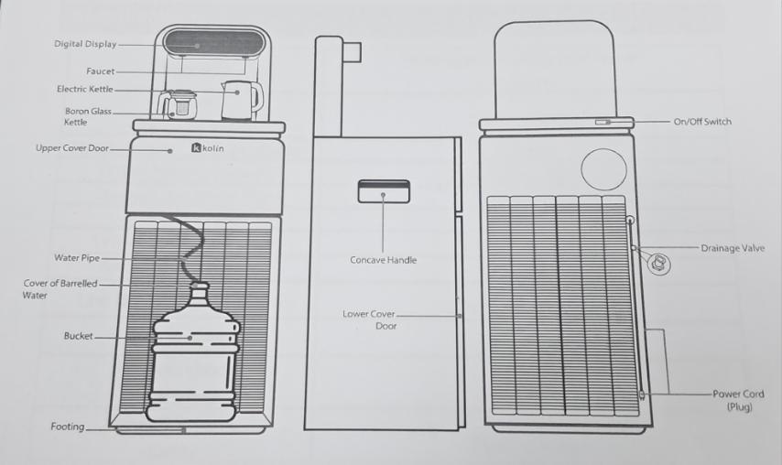
Ipapakita rin ang mga button na ito pati yung remote control

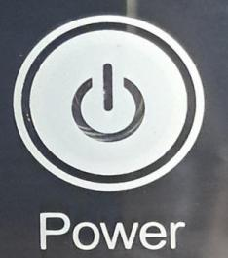
POWER

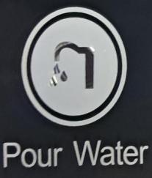
Pour Water



Heat
Cool / Pour Water



Keep Warm

REMOTE CONTROLLER

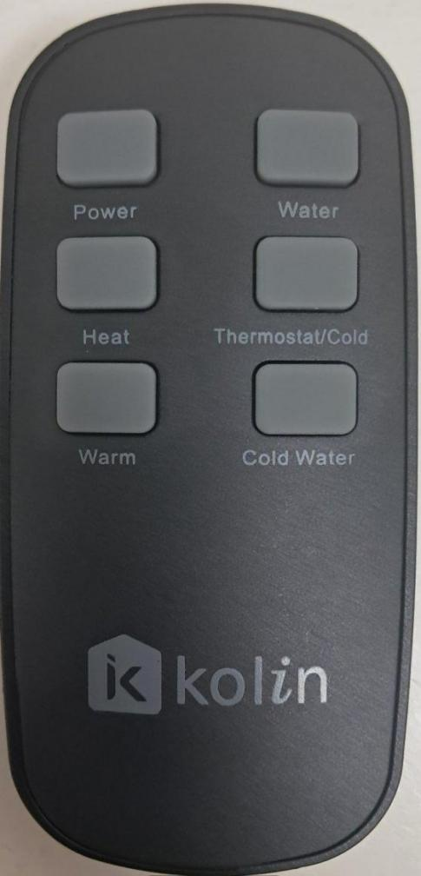
Water
Power

Heat Thermostat/Cold

Warm Cold Water

Reference: Picture of Remote Control (Coffee Tea Bar)

PART 4 OF THE VIDEO: MANUAL OPERATION AND REMOTE OPERATION

Video Suggestion/Edit: Engr Ken’s Suggestion is side by side frame video for Manual Procedure and Remote Procedure to see the difference. (Will provide video for Remote
Procedure)

Videos to use:
Manual Operation:

- Video 10: Plugged in Coffee Tea Bar
- Video 11: Turning on Coffee Tea Bar (with Off Display) (Option 1) and (Option 2) depende kung ano mas magandang kuha

- Video 12: Power Button of the Coffee Tea Bar
- Video 13: Pouring Water for 25 Seconds.

- Insert Picture 13.1: Picture of Pouring Water Half a Kettle

- Video 14: Boiling Water 100 Degrees (I time stamp na lang hanggang umabot ng 100)

- Video 15: Pouring Water at Glass Kettle

- Video 16: Cool Button Operation

- Video 17: Keeping Water Warm Video
Remote Operation:

- Video 12.1 and Video 13.2: Remote: Remote Power Button and Pouring Water for 25 Seconds

- Video 13.2 (Option 2) and Video 14.1: Remote Pouring Water for 25 seconds Option 2 and Boiling Water for 100 Degrees (Time Stamp Video 14.1)

- Video 15.1 and 16.1 : Remote Pouring Water at Glass Kettle and Cool Operation

- Video 17.1 - Remote Keeping Water Warm

VIDEO ABOUT MANUAL OPERATION OF COFFEE TEA BAR:

(Video 11 and Video 12) Power - Connect the Power and turn on the switch at the back. Double Press the Power Icon to turn on the machine. Press once to turn it off.

(Video 13) Pour Water - Double Press the Pour Water Icon to dispense water into the black electric kettle. Press once to stop dispensing.

(Video 14) Heat - Press the Heat Icon once to activate the heating process up to 100°C. Press the Heat Icon once to stop heating.

(Video 15 and Video 16) Cool / Pour Water - Double press the Cool / Pour Water Icon to dispense cold water from the left faucet. Press once to stop dispensing.

Press and hold for 3 seconds to activate the cooling process. Press and hold for 3 seconds to turn it off.

(Video 17) Keep Warm - Press once to activate the thermal insulation plate. Press once to turn it off.

Here are the possible Display Indications that you might encounter on the Digital Display Board of the Coffee Tea Bar.

PART 5 OF THE VIDEO: Display Panel Indication

Videos to Use:
- Video 18: Off Display
- Video 19: E1
- Video 20: E2

Script For Display Indication

Video 18: The OFF light indicates that the Coffee Tea Bar is in Standby Mode.
Video 19: E1 is a safety feature that turns off heat and the right faucet when the black kettle is not in place.
Video 20: E2 refers to the automatic shutdown of the power connection to the electric heating tube when heating without water.

PART 6 OF THE VIDEO: Standby Feature/Adjustments

Videos to use:

- Video 21: Heat Warm - Standby / Off-state
- Video 22: Cool Icon - Standby / Off-state
- Video 23: Heat Boiling Icon - Standby / Off State
- Video 24: Pouring Water Icon Standby / Off State

SCRIPT:
- You might want to adjust the temperature for heating or boiling water, or adjusting the duration of water pouring from the right faucet to the black kettle, or the duration of water pouring from the cool faucet? (Connected to Kolin’s Coffee Tea Bar Standby / Off State)

Kolin’s Coffee Tea Bar has its feature called the STANDBY/ OFF State.

(Video 11) - To activate the standby mode, turn on the power switch (red) located on the back of the product. You will hear a beep sound confirming that the product is in standby mode.
(Video 21): *Video about Heat/Warm* - Hold for 3 seconds to adjust the timer (1–24 hours), with a default timer of 8 hours.

(Video 22): *Video about Cool Icon* - Hold for 3 seconds to adjust the pour time (20–40 seconds), with a default of 25 seconds.

(Video 23): *Video about Heat/Boiling Icon* - Hold for 3 seconds to adjust the pour temperature (50–100°C) in 5°C increments.
(Video 24): *Video about Pour Water Icon* - Hold for 3 seconds to adjust the pour time from the right faucet to the black kettle. (18–50 seconds).
REMINDERS:
- The machine may take a few seconds to fill the cold water tank when you use the cool faucet for the first time.
- Based on the adjusted pouring time you have set, the water will begin to pour after the initial filling, including the filling time.
- The Black Kettle may overflow if the pouring time setting is more than 30 seconds.

- For the default setting of 25 seconds, it dispenses about 500-600 ml of water.

ENDING:

We kindly request you to listen and understand this operational guide, this will enable you to effectively utilize and operate the product to its fullest potential.

Thank you for choosing Kolin as your trusted brand!

