KOLIN’S COFFEE TEA BAR PROPER CLEANING AND MAINTENANCE

FOLDERS TO USE: COFFEE TEA BAR ASSEMBLY AND DISASSEMBLY AND CLEANING AND PREVENTIVE MAINTENANCE

To ensure that your coffee tea bar is always in good working condition, it is important to perform regular maintenance and cleaning.

Here are the possible materials that you will need for cleaning.
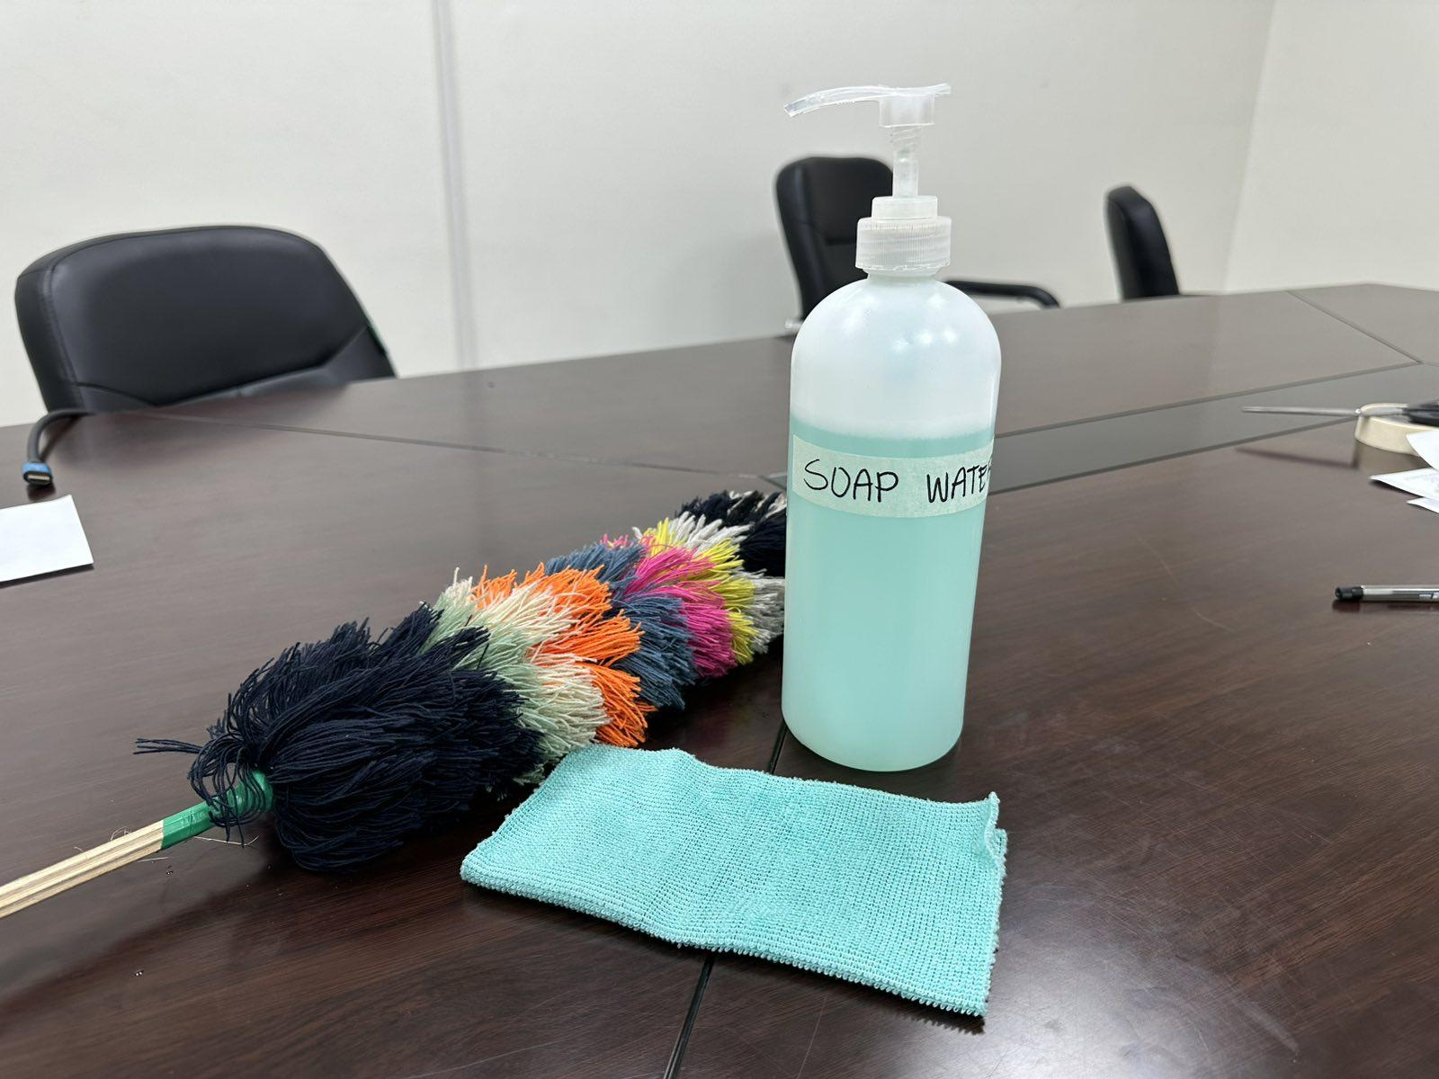
(Feather Duster, Soft Cloth and Soap Water)

Let’s Proceed with the Cleaning of the Coffee Tea Bar

Here are some reminders before you start cleaning:

Do Not Use Abrasive Materials and or Chemical Cleaners.

INSERT: Clip Art na lang of Abrasive Materials and Chemical Cleaners
INSERT: Video 25 - Turn Off Power (Maintenance)

CAUTION: Turn Off the power and unplugged the coffee tea bar before performing maintenance or repairs to prevent accidents.

GENERAL CLEANING:
INSERT THE FOLLOWING VIDEOS:
Video 26 - Cleaning of Lead Control Panel
Video 27 - Cleaning of Display
Video 28 - Cleaning of Concave Handle
Video 29 - Cleaning of Upper Cover Door and Bottom Part
Video 30 - Cleaning of Cover of Barrelled Water

1. Use a soft cloth and warm, soapy water to clean the lead control panel, display panel and other surfaces of the coffee tea bar.

________________________________________________________________

INSERT:

Video 31 - Cleaning of Back Part

2. Wipe away any dust from the back of the dispenser to enhance efficiency.

________________________________________________________________

INSERT:
Video 32 - Cleaning of Black Kettle
3. The Black Electric Kettle can be scrubbed by soft cloth and can not be immersed in water for cleaning.
Note: Do not wash it with a dishwasher.
INSERT:

Video 33 - Cleaning of Boron Glass Kettle

4. On the other hand, the boron glass kettle can be immersed in water and can be cleaned with a dishwasher.
PREVENTIVE MAINTENANCE

INSERT: Kahit puro cliparts na lang na related sa mga statement.

- Initial Set Up - Allow the unit to sit upright for 2 hours. This will reduce the possibility of a malfunction in the cooling system due to handling during transportation.

- After properly installing the water container in the dispenser and ensuring the secure insertion of the water probe into the bucket, plug the unit.

- If the coffee tea bar will not be used for an extended period (more than 3 days) disconnect the power supply and water source, and drain any remaining water from the product.
INSERT: Video 34 - Draining of Water

- Keep the coffee tea bar’s power cord, and plug away from water or other liquids.

- . Avoid touching the power cord with wet hands or bare feet.

- Keep the Coffee Tea Bar away from high temperatures, open flames, moisture, and sharp edges to prevent damage, malfunctions or fire hazards.

- In case of water leakage, immediately switch off the power and drain all water from the machine. Contact our Kolin Hotline number or your local dealer for assistance by professional service personnel.

Customer Hotline: (02) 8-852-6868
Text Hotline: (0917)-811-8982
Email: customerservice@kolinphil.com.ph

- Do not attempt to repair it by yourself.

ASSEMBLY AND DISASSEMBLY

INSERT:

ELECTRICAL SCHEMATIC DIAGRAM
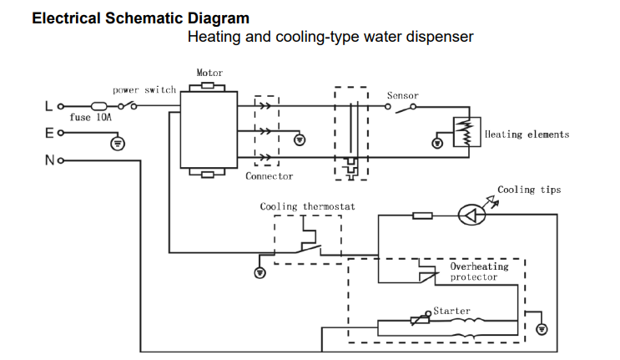

DISASSEMBLY:

- First, Remove the screws at the back, there are two on each side. (Left and Right) a total of four securing the faucet assembly.

INSERT: Video 35 - Disassemble 3
SUGGESTION: Animation encircles the screws that need to be removed.

- Next, unscrew the four screws located at the front portion.

INSERT: Video 36 - Disassemble 1

- The third step is to carefully lift and disconnect the silicone hose and display sockets.

INSERT: Video 37 - Disassembly of Faucet Assembly

- After taking out the faucet assembly, remove the seven screws at the back. Gently lift the rear plastic cover. You will now have access to the Display Board and Silicone Hoses.

INSERT: Video 38 - Removing of Hose 2

- Unscrew the screws securing the Display Board

INSERT: Video 38 - Removing of Hose 2

- Detach the silicone hose.

INSERT: Video 38 - Removing of Hose 2

- Lift the touch glass panel to expose the PCB, Water Pump, Sensor, Compressor and Water Tank.

INSERT: Video 39 - Disassemble 4
INSERT: Label of Parts for Video 39
- To remove the thermistor, cut a small section of the water tank’s styrofoam and carefully pull the thermistor out.

INSERT: Video 39 - Disassemble 4

- Detach the PCB

INSERT: Video 40 - Removing of PCB

- Overview of Parts: Recap

INSERT:

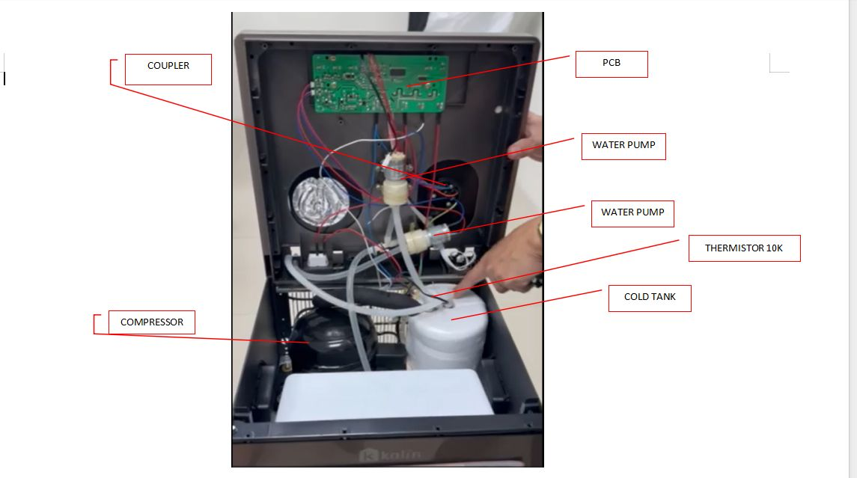

EMPHASIZE:

You may experience the "E5 Error," which indicates that either the PCB or the Coffee Tea Bar's thermistor is malfunctioning.
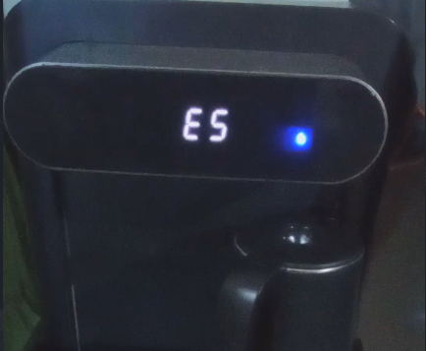
INSERT:

ASSEMBLY OF COFFEE TEA BAR

VIDEOS TO USE:
Video 5 - Assembly of Coffee Tea Bar Part 1
Video 6 - Assembly of Coffee Tea Bar Part 2
Video 7 - Assembly of Coffee Tear Bar Part 3
Video 8 - Assembly of Coffee Tea Bar Part 4

For Video 5 - Silicon Tubes Connector and Wire Clip Connector (papakita lang ung parts)

For Video 6 - Silicon Tubes Connector and Wire Clip Connector (Papakita lang ulit ung parts)

For Video 7 - Insert the small water tubes (silica gels) tightly into the vertical post on the machine's water outlet.

-EMPHASIZE: Ensure that the tube with hot water markings is connected to the hot marking of the water outlet on the machine’s table board.

- Also, connect the wire clip connector to its appropriate color (white and black) for the electrical connection.

For Video 8 - Align the water faucet assembly on the machine table with the screw holes located at the back of the base of the machine.

