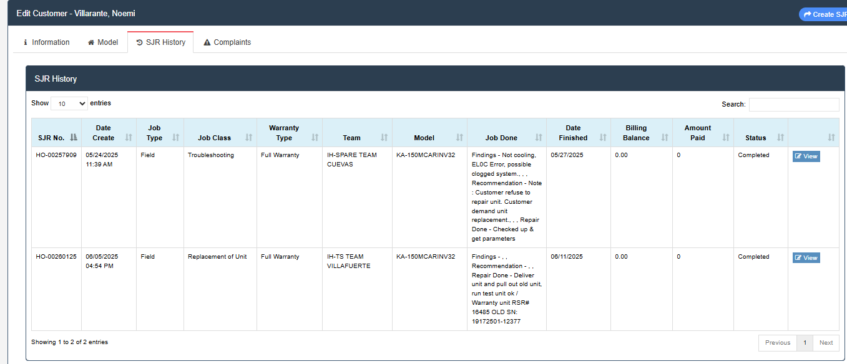
Villarante, Noemi
769 Edsa LM: Near Landbank Malibay Brgy.144 Zone 17 Pasay City Maynila
KA-150MCARINV32
19172501-12377
DOP: May 16, 2025
Date Customer Complained: May 24, 2025
8 days upon DOP
Dealer: Azeedal Home Trading
- EL0C Error, Conducted Leak Test, No leak found
- Possible Clogged System
Setting Temp: 17 degrees
Discharge : 28 degrees
Intake: 29 degrees
Ampere: 2.6A
Wattage: 661.4W Voltage: 233V

