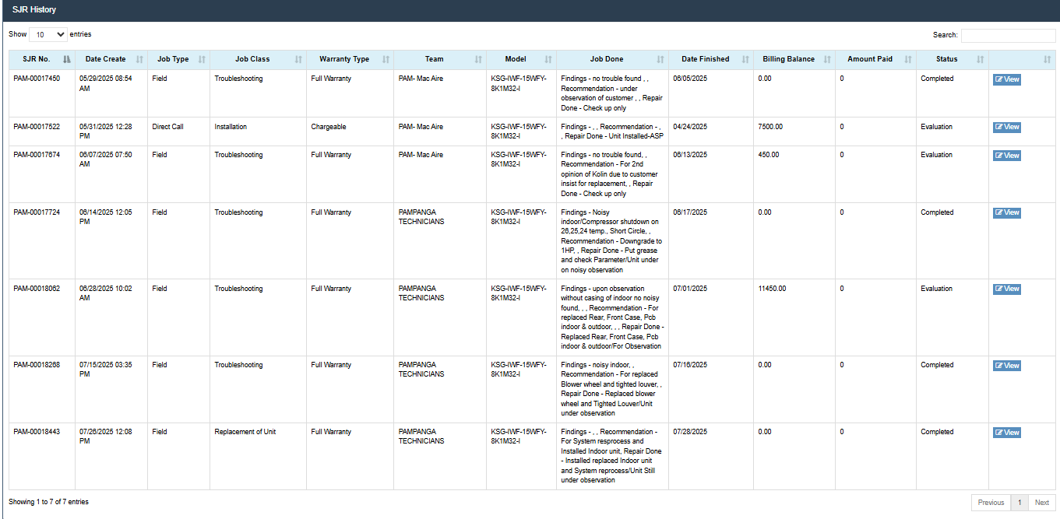
Calpito, Arnin Kaye
Brgy. Sta. Ines Paniqui Tarlac
KSG-IWF-15WFY-8K1M32-I
IDU: 18452407-18832 / ODU: 18462407-18685
DOP: April 21, 2025
Date Installed: April 24, 2025
Dealer: Mega Savers
Installer: MAC AIRE
Complaint: Auto on & off of compressor
- Auto on & off outdoor unit.
-Replaced indoor pcb, outdoor pcb sensors and conduct system reprocess, still auto on and off.

