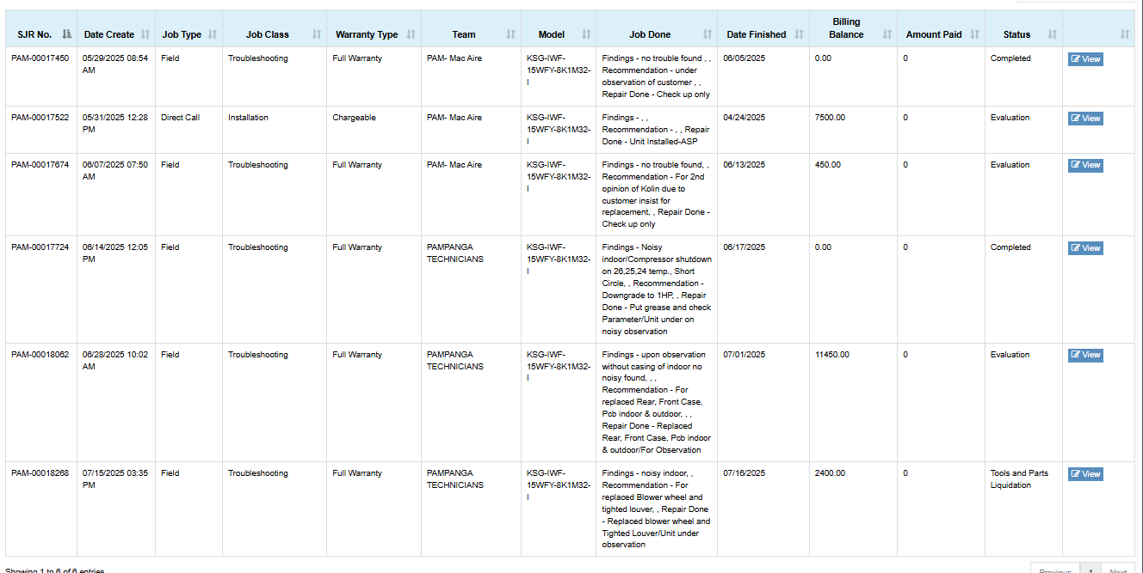
Calpito, Arnin Kaye
Brgy. Sta. Ines Paniqui Tarlac
KSG-IWF-15WFY-8K1M32-I
IDU: 18452407-18832 / ODU: 18462407-18685
DOP: April 21, 2025
Date Installed: April 24, 2025
Dealer: Mega Savers
Installer: MAC AIRE
Complaint: Noisy Indoor Unit / Auto on & off of compressor
- Auto on & off due to shortcycle 10 square meter lang po ang area. Already explained po twice regarding dito kay customer.
-Noisy Indoor unit. Maingay po talaga yung indoor unit may lumalagitik na sound. Already replaced Front Case, Rear Case, pinalitan din nila ang PCB IDU.
-Nagpalit na ren po ng blower wheel, naglagay ng grease. Re-tightened of louver still noisy. Pag tinanggal po ang kaha walang ingay, pag nakalagay meron pong lagitik talaga.

