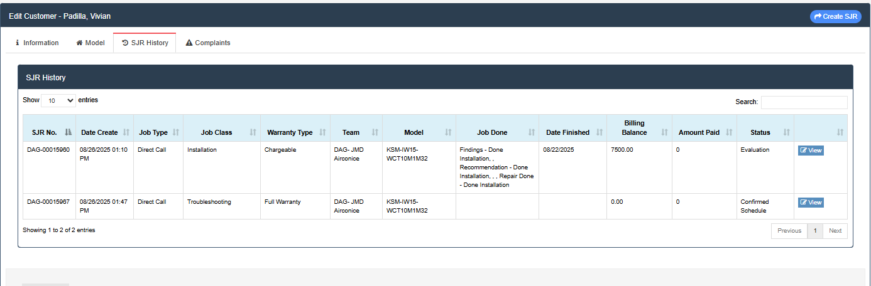
Padilla, Vivian
Sta Ana Agoo La Union
KSM-IW15-WCT10M1M32
IDU: 18632501-28185 / ODU: 18642503-29977
DOP: 08/22/2025
DOI: 08/27/2025
DEALER: CSI WAREHOUSE
INSTALLER: JMD Airconice Repair Shop
1 day old lang nagamit.
EH03 Error (indoor fan speed is operating outside of the normal range)

