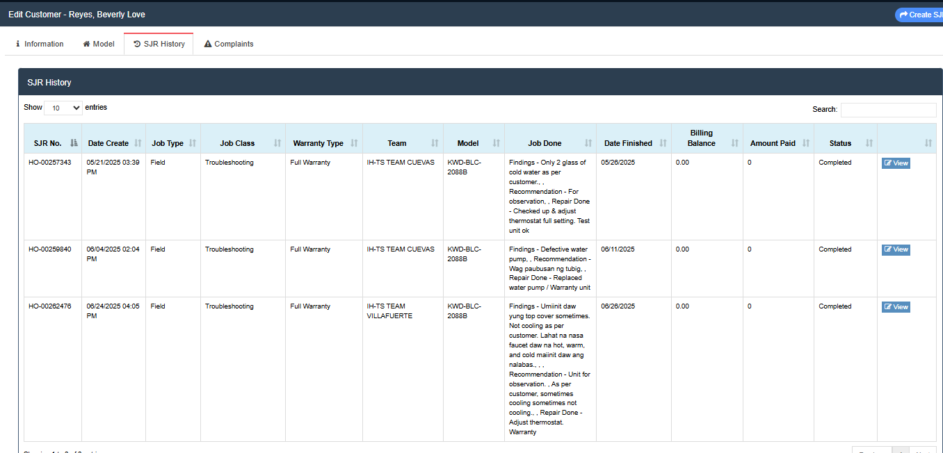
Reyes, Beverly Love
23 Baesa Road Brgy. Baesa Quezon City
KWD-BLC-2088B
01362408-14886
DOP: 05/18/2025
DEALER: WESTERN
Nakalocka and nakakabit naman daw po yung rod
Mainit daw po yung top cover
Hot water dispensing in faucets.
Offer warranty extension and schedule for IH customer refuse, since nagreport daw po siya 3 days upon DOP.
Napagbigyan irepair 1st 2 months.

