WATER DISPENSER (KWD-BLC-2088B)

OPERATIONAL:

Introduction: Showcasing of the Water Dispenser (Model: KWD-BLC-2088B)

SCRIPT:

Kolin Philippines International Incorporated presents the “Kolin Water Dispenser” it provides convenient access to cold, hot, and room temperature water anytime you need it.

Whether you want a refreshing glass of chilled water, hot water for tea or coffee, or room temperature water for everyday hydration this dispenser offers a reliable and efficient solution.

Designed efficiency and safety in mind, it is perfect for homes, offices and other spaces where quick and versatile access to clean water is essential.

(VIDEOS TO USE: Water Dispenser Front Part, Left Part, Back Part, and Right Part)

(Note EDIT: When it comes sa showcasing mag apply na lang ng mga applicable cliparts na tutugma doon sa mga description sa water dispenser)

KOLIN WATER DISPENSER IMPORTANT SAFETY INSTRUCTIONS

- This appliance is suitable for use by individuals aged 8 years and above, as well as those with reduced physical, sensory or mental capabilities.

- Children should not be allowed to play with the appliance, and user maintenance should always be conducted under adult supervision

- To ensure the product’s reliability, please make sure to connect the water dispenser to a stable power supply using the provided power cord. Avoid using extension cords or adapters, as they may pose a safety risk.

- Only use clean and portable water with the water dispenser. Regularly clean the water tank and water faucets.

(VIDEO EDIT: Use applicable cliparts per safety instructions)

KOLIN WATER DISPENSER PARTS AND FUNCTION
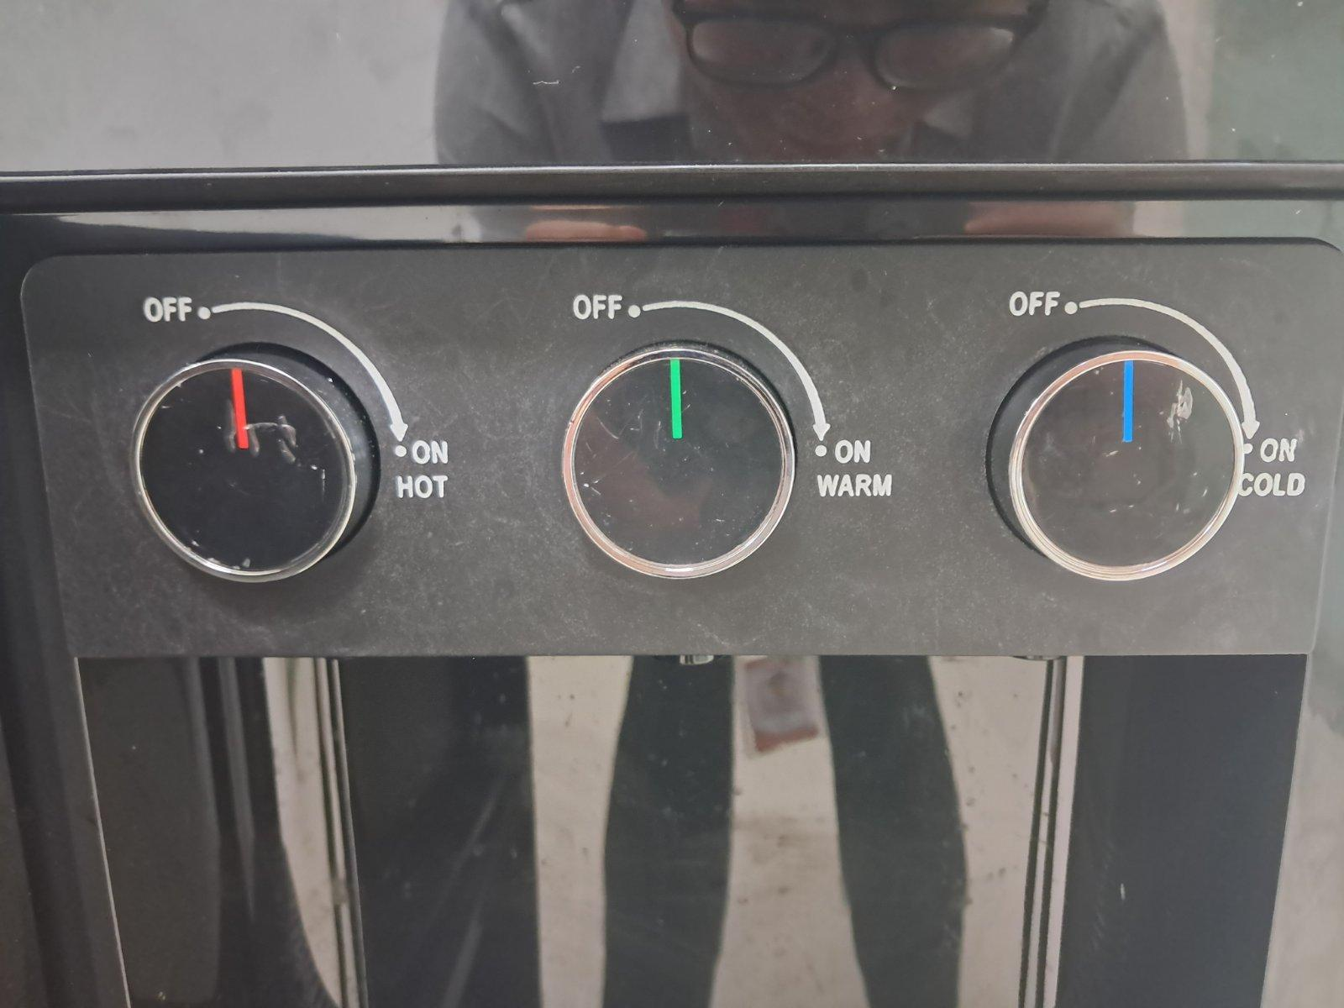

(NOTE: Magbase po sa Manual
Regarding sa Label)

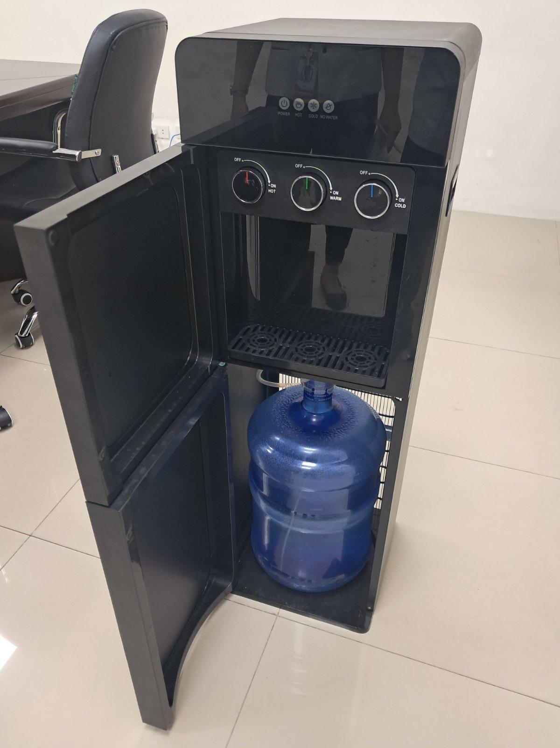

(Mag base din po sa manual for
Each label ng mga parts)

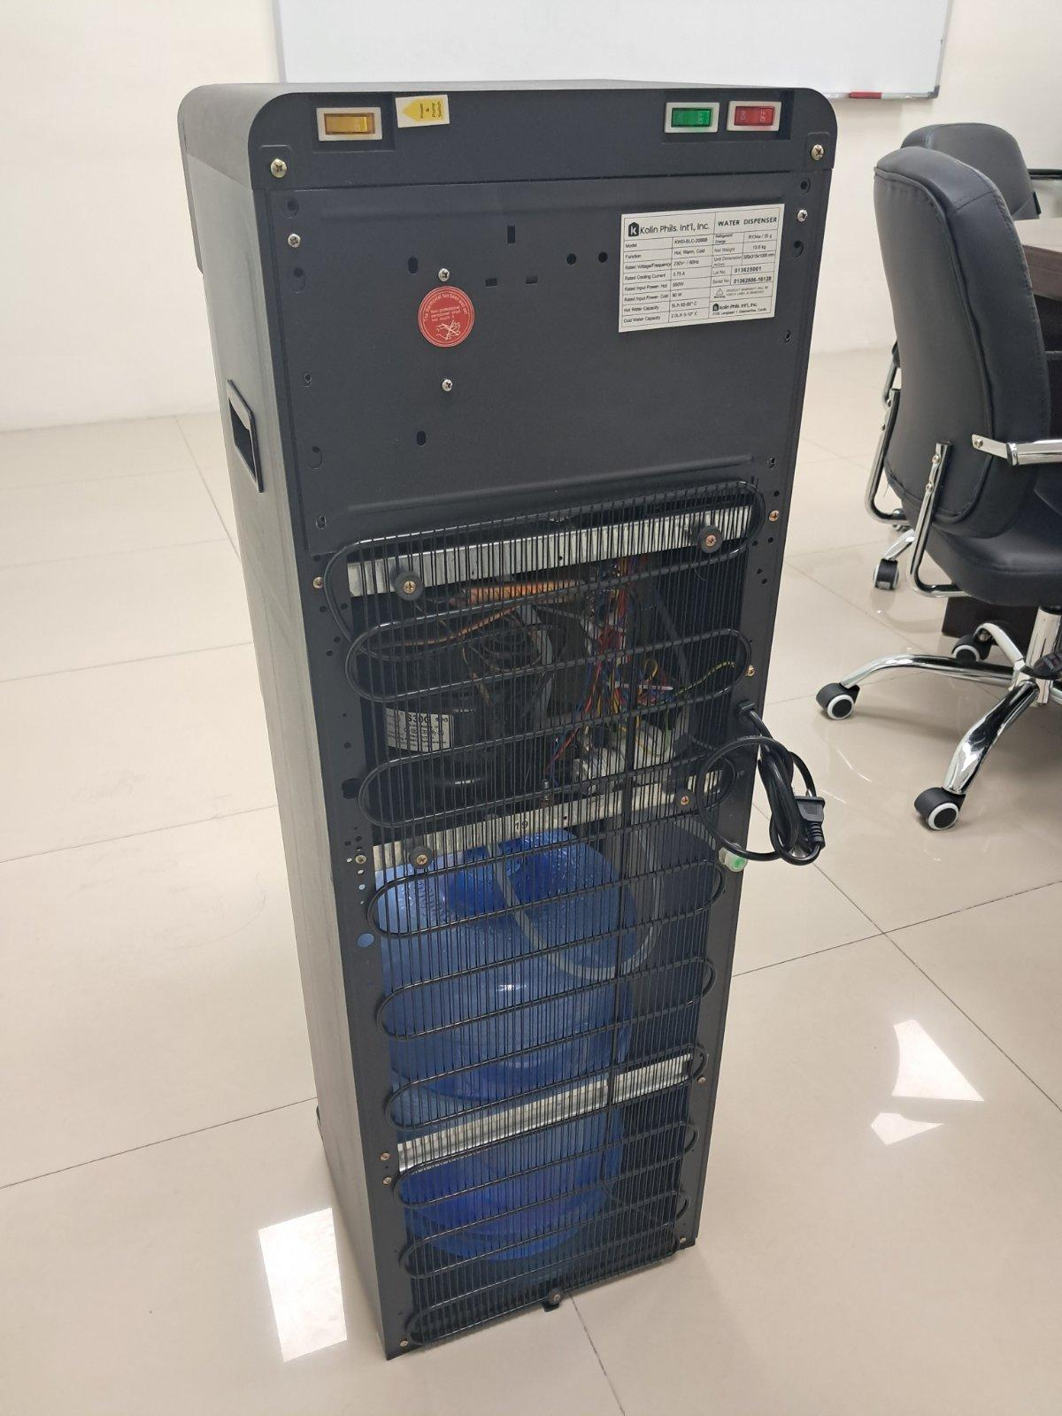

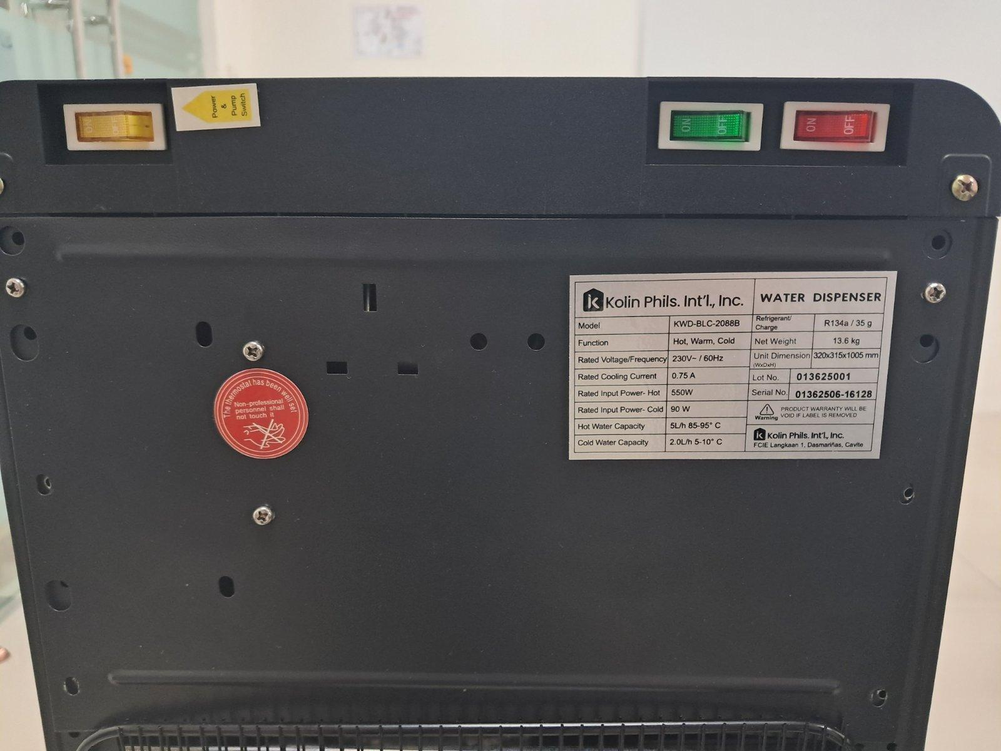

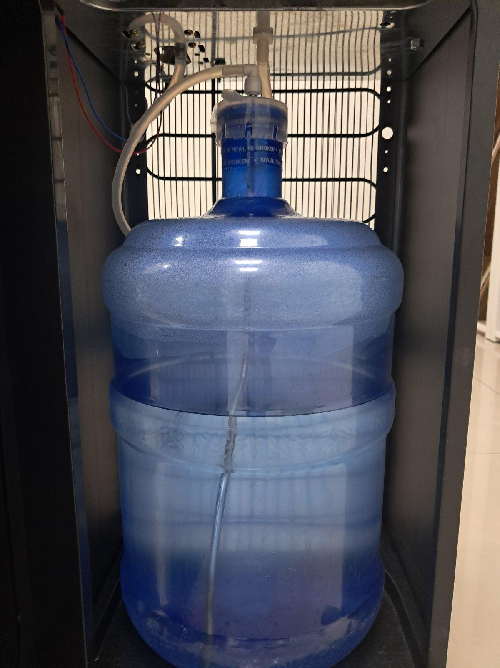

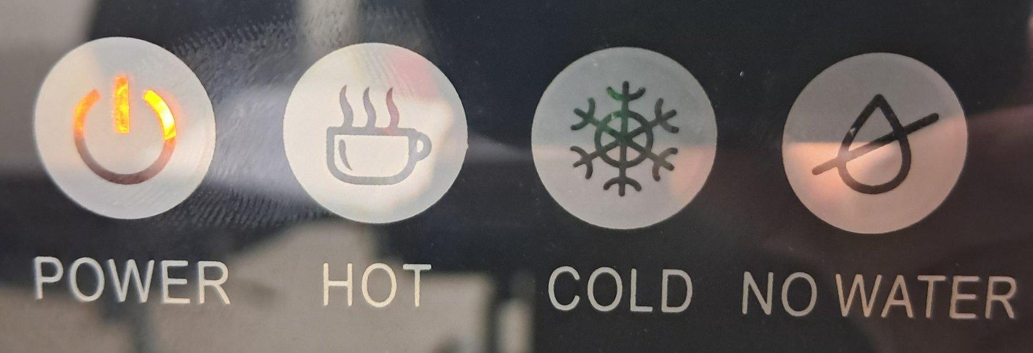
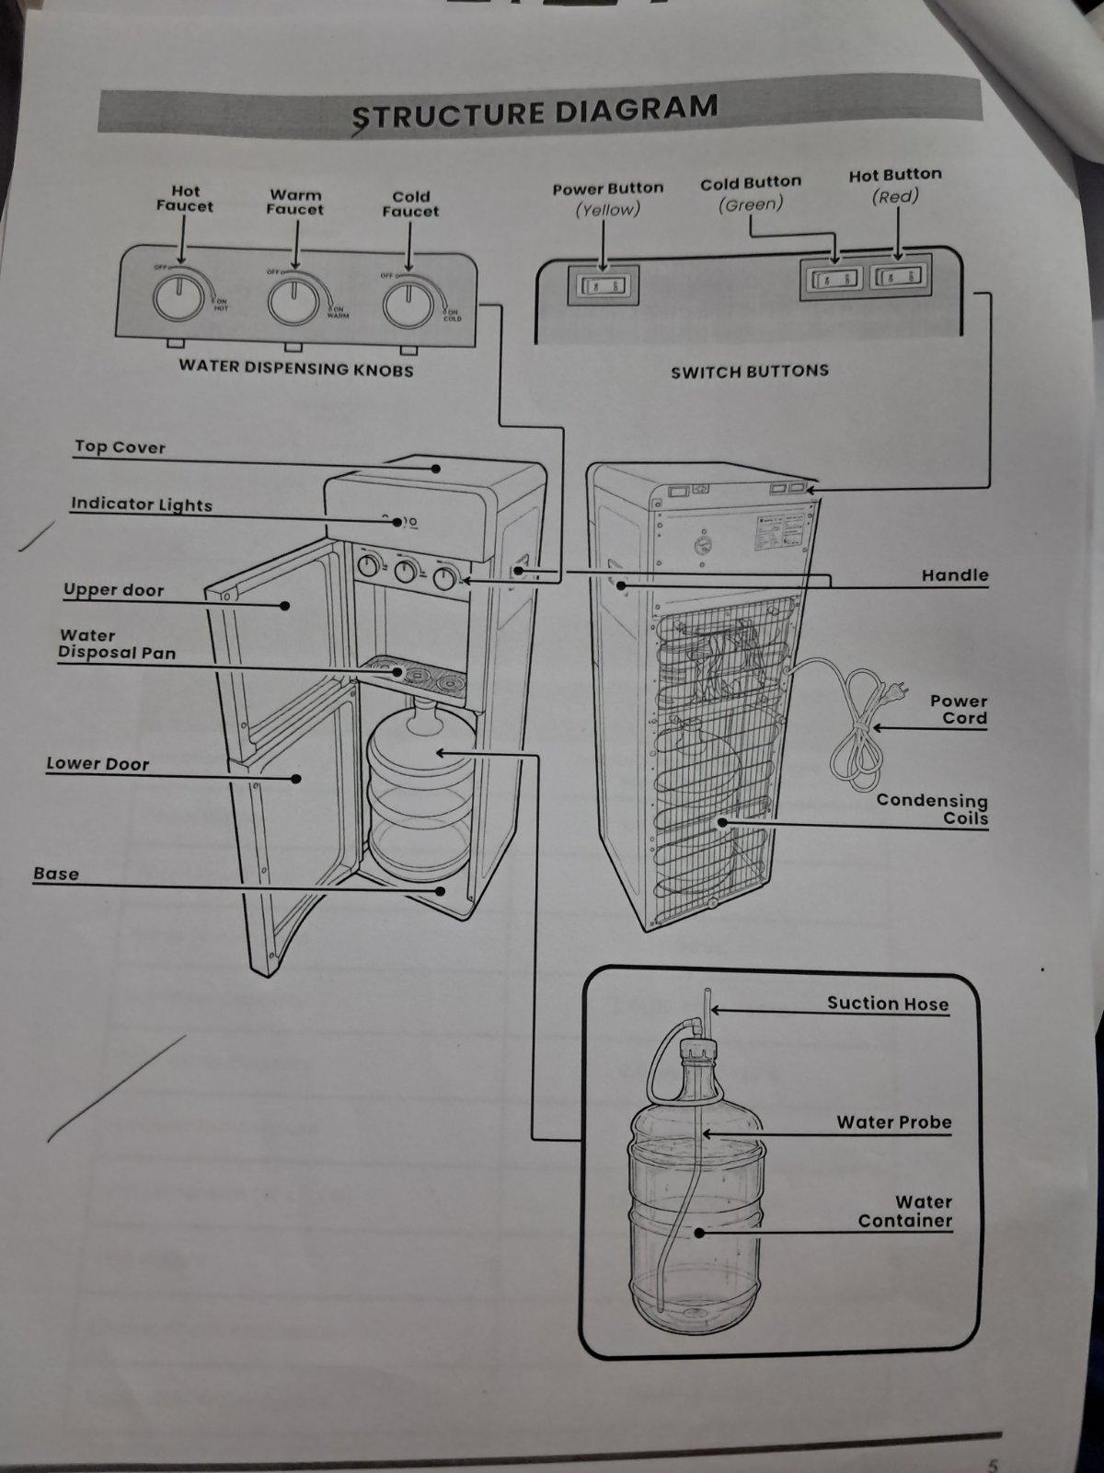

Paki gamit po ito as reference ginaya po namin sa bawat mga pictures specially sa pagdagdag ng mga labeling ng parts.

____________________________________________________________

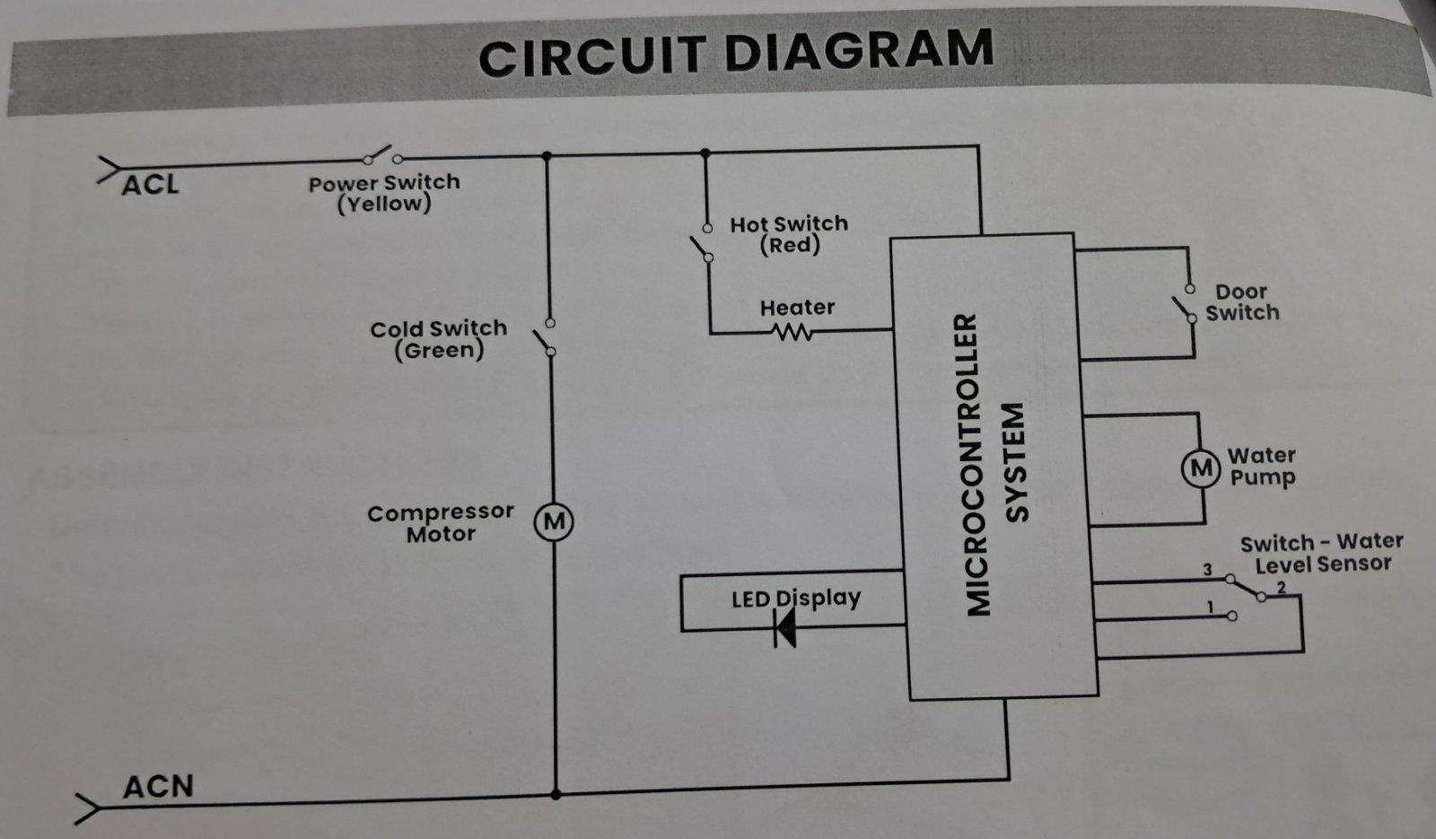
Circuit Diagram of Water Dispenser
(Pa include sa video mag base na lang ng actual picture sa Manual)

TAKE NOTE:

In using the Water Dispenser, always place the water disposal pan on the water dispenser drawer to catch any droplets when filling water.

SWITCHED BUTTONS:

- Power Button (Yellow Button) - Pressing the ON side of the power will turn on the unit, and the Power Indicator light will illuminate.

- Activating this button also turn the water pump on, which will fill the water tanks until they are full. However, if the lower door is open, the pump will not operate.

(Video to Use: Turning on the Switch Buttons, VIDEO SUGGESTION: pa pause ng vid sa tuwing may pipindutin na button and lagyan ng arrow ung mga colored switch buttons)

- Cold Button (Green Button) - Pressing the ON side button will start the cooling operation.

- The Cold Indicator will illuminate to show that the cooling process is in progress.

(Video to Use: Turning on the Switch Buttons)

- Hot Button (Red Button) - Pressing the ON of the Hot Button will start the heating operation.

- The Hot Indicator will illuminate to show that the heating process is in progress.

(Video to Use: Turning on the Switch Buttons)

If you press all the buttons, this is what it would look like:

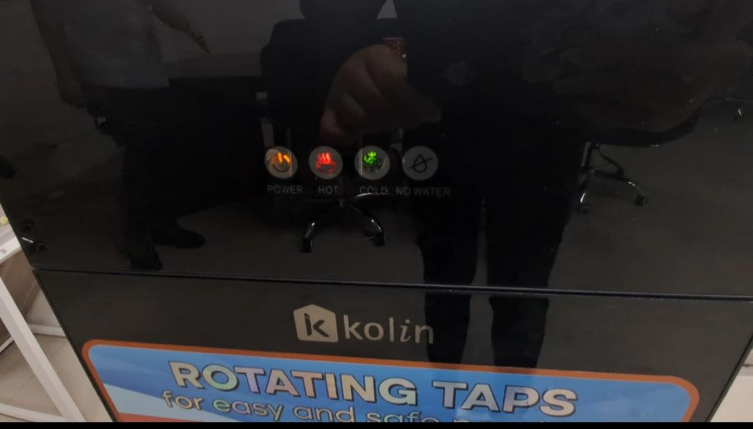

(VIDEO: You can also use ung turning on switched buttons na video sa ending yan pinakita)

____________________________________________________________

INDICATOR LIGHTS:
(Gamitin na lang yung manual as reference for each indicator lights or may mahanap na mas better animation much better)

- POWER - the Power Indicator remains illuminated whenever the Power Button is switched ON.

- HOT - The Hot Indicator will illuminate to indicate that the hot tank is in the heating process.

- Once the water temperature reaches approximately 85 to 95 degrees celsius, the indicator will turn off.

- When the water cools down to a predetermined lower temperature the indicator will light up again as the heating progress restarts.

- COLD - The Cold Indicator will illuminate to indicate that the compressor is turned on and in cooling process.

- Once the water temperature reaches approximately 5 to 10 degrees celsius, the Cold indicator will turn off.
- When the water rises to a predetermined higher temperature, the indicator will light up again as the cooling process restarts.

- NO WATER:
Low Water Tanks, Gallon Still Has Water
- The No Water Indicator will light up (blinking). The pump will automatically turn on to refill the water tank once it detects that the water level in the tanks is low.
- Once the tanks are full, the indicator will turn off.

Low Water Tanks, Gallon is Empty
- The No Water Indicator will light up (blinking)

(VIDEO TO USE: No Water Indicator)

____________________________________________________________

WATER FAUCETS:

HOT - After pressing the Hot Button, wait until the Hot Indicator light turns off. To dispense hot water, place a mug or heat-resistant cup.
AVOID: using plastic cups as they melt (kahit clipart na lang)

- Turn the knob clockwise until the desired amount is dispensed, then close it gently and fully to prevent leaks. Always use caution when handling hot water to avoid burns.
(Video to Use: HOT Water Faucet)

WARM - To dispense warm water, place a clean cup/mug under the warm water knob. Turn the knob clockwise until the desired amount is dispensed, then close it gently and fully prevent leaks.

(Video to Use: WARM Water Faucet)

COLD - To dispense cold water, place a clean cup/mug under the cold water knob. Turn the knob clockwise until the desired amount is dispensed, then close it gently and fully prevent leaks.

(Video to Use: COLD Water Faucet)

____________________________________________________________

PREVENTIVE MAINTENANCE AND CLEANING OF WATER DISPENSER

- Removing of Existing Water

(Videos to Use: Turn all Switch Buttons Off and Unplug the Unit
: Move Away From Wall Picture
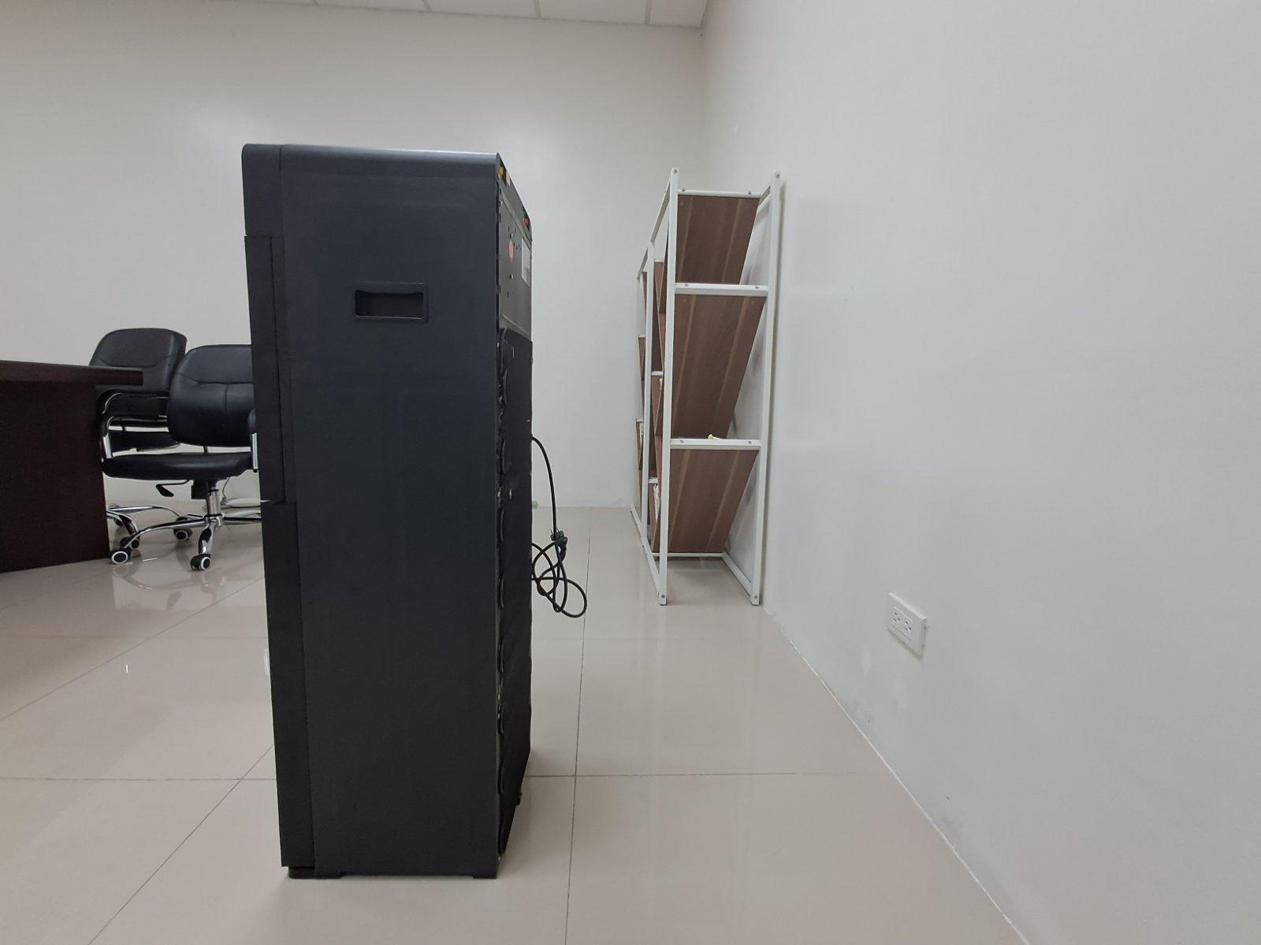
: Remove the Water Probe Container Video
: Removing of Drain Plug and Place a Bucket
Step By Step:
- Turn all the switch buttons OFF.
- Unplug the Unit
- Make sure that the water dispenser is away from a wall.
- Remove the water probe from the container.
- Place a bucket below the drain plug.
- Remove the drain plug and drain water.
- Reattach the drain plug,

2. SANITIZE THE COVER WATER CONTAINER FAUCETS
- Use a soft cloth and wipe the water container cover and the faucet area thoroughly.

(Video to use: Sanitizing the Cover of Water Container and Faucets)

OTHER MAINTENANCE AND SAFETY PRECAUTIONS:

Materials needed for cleaning: soft cloth, water and feather duster (kahit cliparts na lang po)

- Always turn off the switch and unplug the unit before performing maintenance.
(Video to Use: Turning off Switch and Unplug Unit)

- Avoid using detergents or harmful chemicals on the water container (kahit cliparts na lang po)

- Wipe the outer surface with a soft, damp cloth, while the back area of the Water Dispenser uses a feather duster to clean it properly.
(Videos to Use: Cleaning outer surface 1, Cleaning Outer Surface 2, Cleaning the Bottom Part (Suction Hose) & Cleaning Back Area)

If you have any concerns, please contact the following:
Customer Hotline: (02) 8852-6868
Email:

Thank you for choosing Kolin as your trusted brand for appliances!

